Design Project Report: Group 21

ECE 271 - Spring 2019

Press CTRL + ALT + A, then CTRL + ALT + H for Document Outline

**Group 22 consists of**: Eric Prather (ID 932580666), Hamza Swati (ID 932907049), James Yang (ID 932727269), and Nicholas Matsumoto(ID 932709078)

**Controller Selection**: All controllers.

[Assignment Description](https://oregonstate.instructure.com/courses/1719897/assignments/7506805)

[Project Drive (Web Interface)](https://drive.google.com/open?id=1Wn0P4xyyiVeV2fFKjfGl8rIzS3c4Seh4)

# Table of Contents

**Table of Contents** **2**

**Introduction** **4**

What was accomplished: 5

**Top Level Diagram** **6**

**Controller Descriptions** **7**

**Hardware Diagram** **10**

PC/2 Hardware Diagrams 11

**Functional Unit Tests** **13**

NES Input A 13

NES Input B 13

NES Input Select 14

NES Input Start 15

NES Input Up 16

NES Input Down 17

NES Input Left 18

NES Input Right 19

**Individual Block Tests** **20**

Switch 20

Maximized Counter 21

Hexadecimal Notation Shift Register C 21

Sequential Writer 22

Sequential Listener 23

NES Shift Register C 23

NES Shift Clock 25

NES Receiver 25

**Documentation** **26**

Top Layer 27

PS/2 System Specification 27

NES System Specification 27

Functional Units 27

Listener 27

Sequential Writer 28

Individual blocks 29

Selection Switch 29

Counter 29

Maximized Counter 30

Negated Counter 31

Negated Maximized Counter 32

Hexadecimal Notation 33

NES Clock Holder 34

NES Counter 35

NES Data Mux 35

NES Greater Comparator 36

NES Latch Counter 36

NES Lesser Comparator 37

NES Lesser Equal Comparator 37

NES Load Handler 37

NES Shift Register 38

**Extra Feature: Graphical Synthesis of a Hash Function on an FGPA** **40**

Color Hash 40

VGA Driver 41

**Appendix A: System Verilog Code** **43**

NES ClockHolder.sv 43

counter.sv 43

NES DataMux.sv 44

NES GreaterComparator.sv 44

NES latchCounter.sv 44

NES LesserComparator.sv 45

NES LesserEqualComparator.sv 45

NES loadHandler.sv 45

NES ShiftRegisterC.sv 45

ops.sv 46

core.sv 50

extra_credit.sv 54

top.sv 56

l6_modules_fixed.sv 59

**Appendix B: ModelSim Macros** **65**

list_macro.txt 65

sequ_macro.txt 69

# Introduction

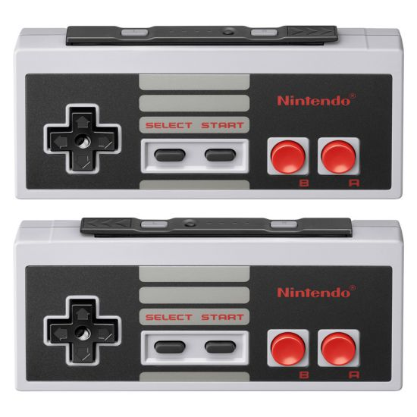

**Figure 1.1: Original NES Controller released in 1983.**

The goal of this final project is to be able to showcase our knowledge and abilities that we have learned in the ECE 271 curriculum. We are asked to implement an NES (Nintendo Entertainment System) controller and a PS/2 controller that takes in inputs and outputs them onto a seven-segment display on an FPGA board. The NES controller can be programmed by pulsing the latch for the shift register, having a data pin that takes in all of the inputs, and a clock to go through and output each input serially. The PS/2 controller follows the same logic, but with some minor differences.

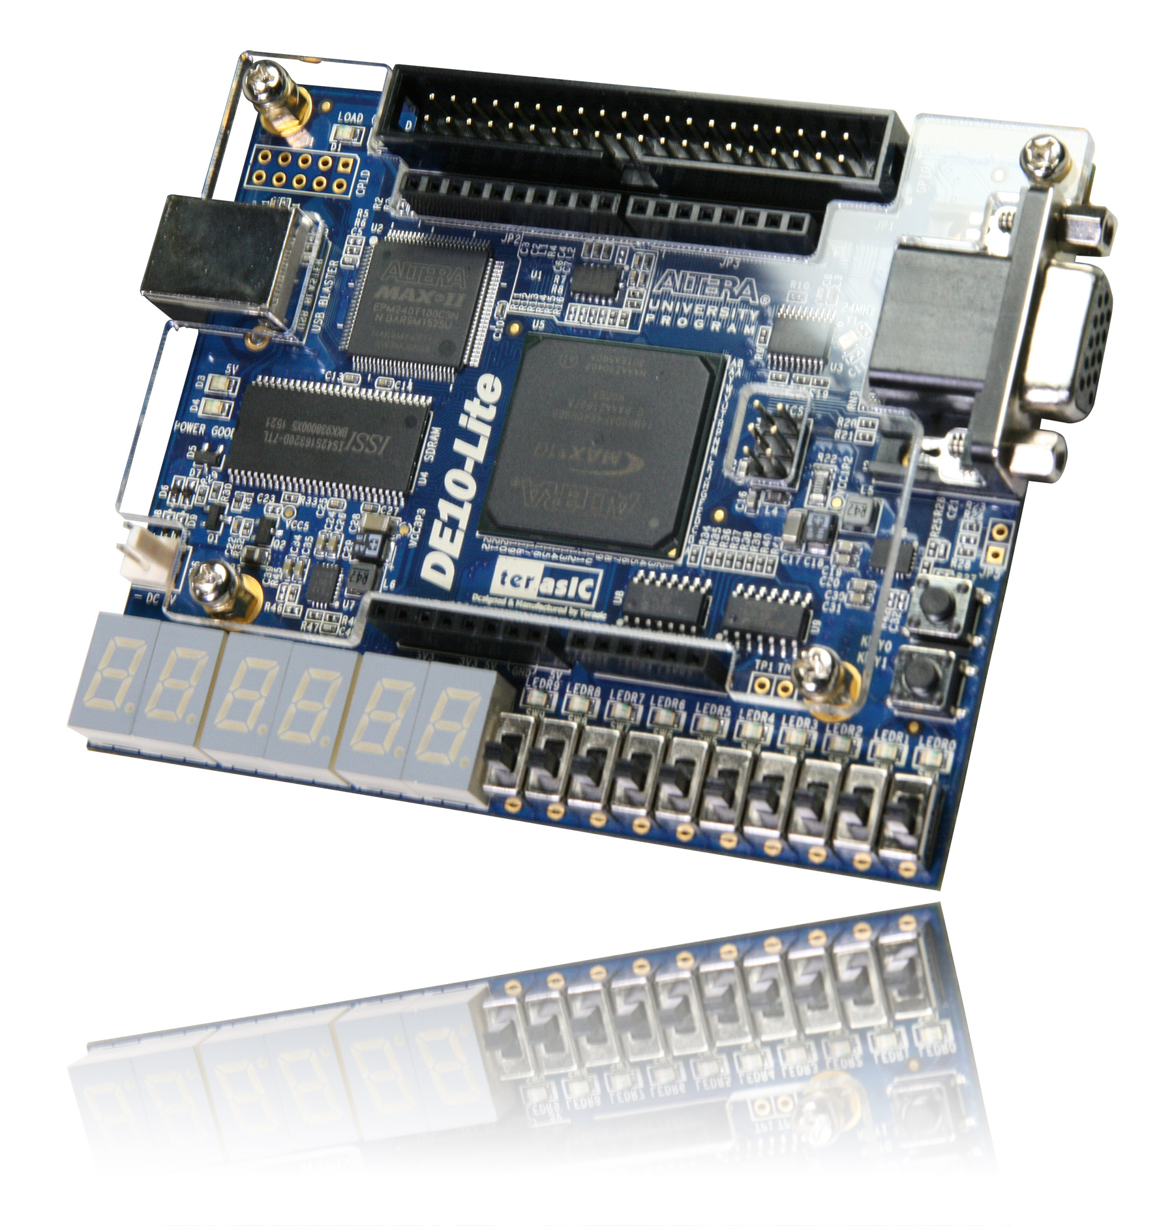

**Figure 1.2: FPGA DE10-Lite Board.**

The project itself has been sourced by many different websites that have completed and written step-by-step procedures on completing these tasks. Each of these websites describe their own unique caveats in their implementations and warn the user very briefly about these issues. The website Mr. Shuman has provided on the NES controller regarding Arduino implementation describes small aspects of the controller that need attention; these issues include the fragility of the PCBs, holding the NES protocol for 12 microseconds, asynchronous outputs, etc.

## What was accomplished:

1. Supports input/output logic from the NES/PS/2 controller to the FPGA.
2. (Extra Credit) Take in inputs from the PS2 keyboard and output different colors through the VGA onto a monitor.

# 

# Top Level Diagram

For a textual description of the system’s core functionality, inputs, and outputs, see Top Layer.

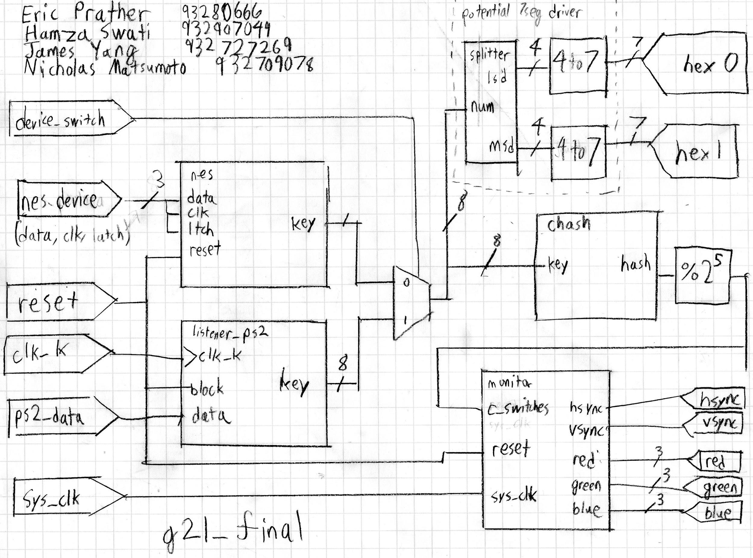

**Figure 1.1: PS/2 System Diagram**

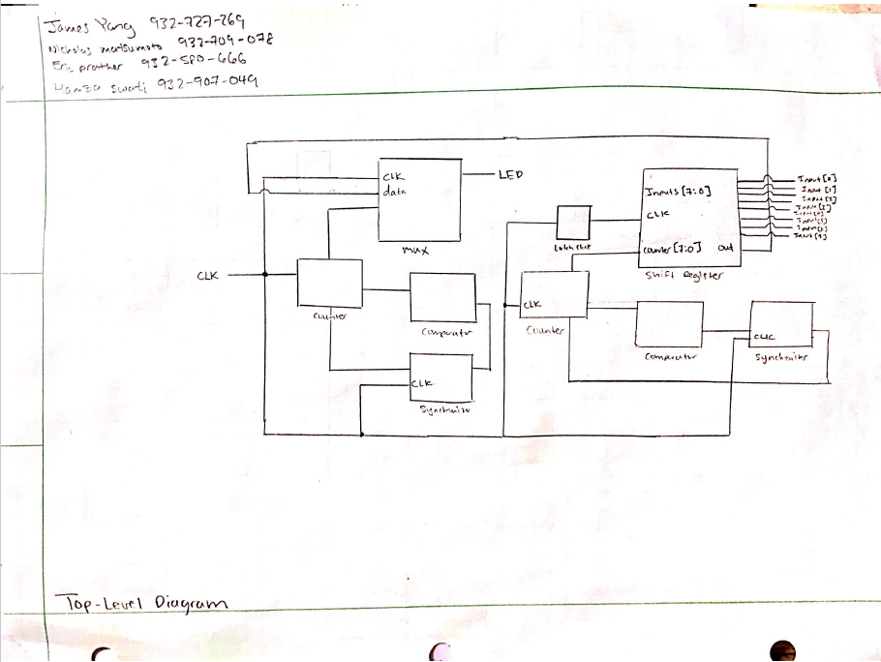

**Figure 1.3: NES Controller Top Level Diagram.**

# Controller Descriptions

The NES controller has 8 total inputs - A, B, Start, Select, Up, Down, Left, and Right. The data is stored in an 8 bit shift register that has an input of CLK and LATCH with an output to DATA. The schematic within an NES controller is represented in Figure 1.4. The shift register will grab the inputs and utilize a latch to transition the logic high and low bits. The duration of logic high must stay at least 12 microseconds in order to register, and the data output will rotate to the next value with every high end of the clock.

# 

**Figure 1.4: Schematic of the insides of the NES controller**

The PS/2 controller has a male and female input/output that is reversed in order based on whether it is a plug or a socket. The plug has the odd numbers on the left with evens on the right, while the socket has the opposite. The 6 pins correlate to the figure described below. They consist of the data, unimplemented, ground, VCC, clock, and unimplemented.

# 

**Figure 1.5: Table of the ports with the designated pin locations.**

The input is a DC 5V with two resistors in parallel with 2 NPN transistors going to a 4 bit input microcontroller with ports A and B being connected to data and clock and ports C and D through a transistor. There are starting, data, parity, stop, and acknowledge bits. Data sent from the device is read through a clock signal, and the data is read on the falling edge of the clock. The frequency that it must be set at ranges from 10-16.7kHz, and timing is crucial in having a functioning PS/2 controller.

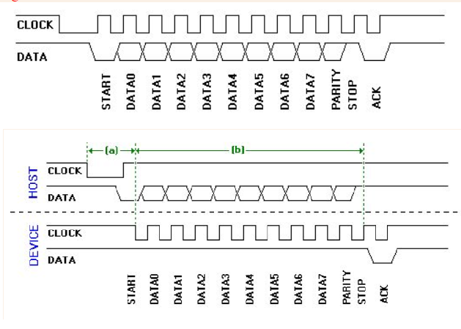

**Figure 1.6: Depiction of the clock in relation to all of the bits from the PS/2 Controller.**

# Hardware Diagram

To see a textual outline of the system, including detailed operations and functions of specific blocks, see Individual Blocks.

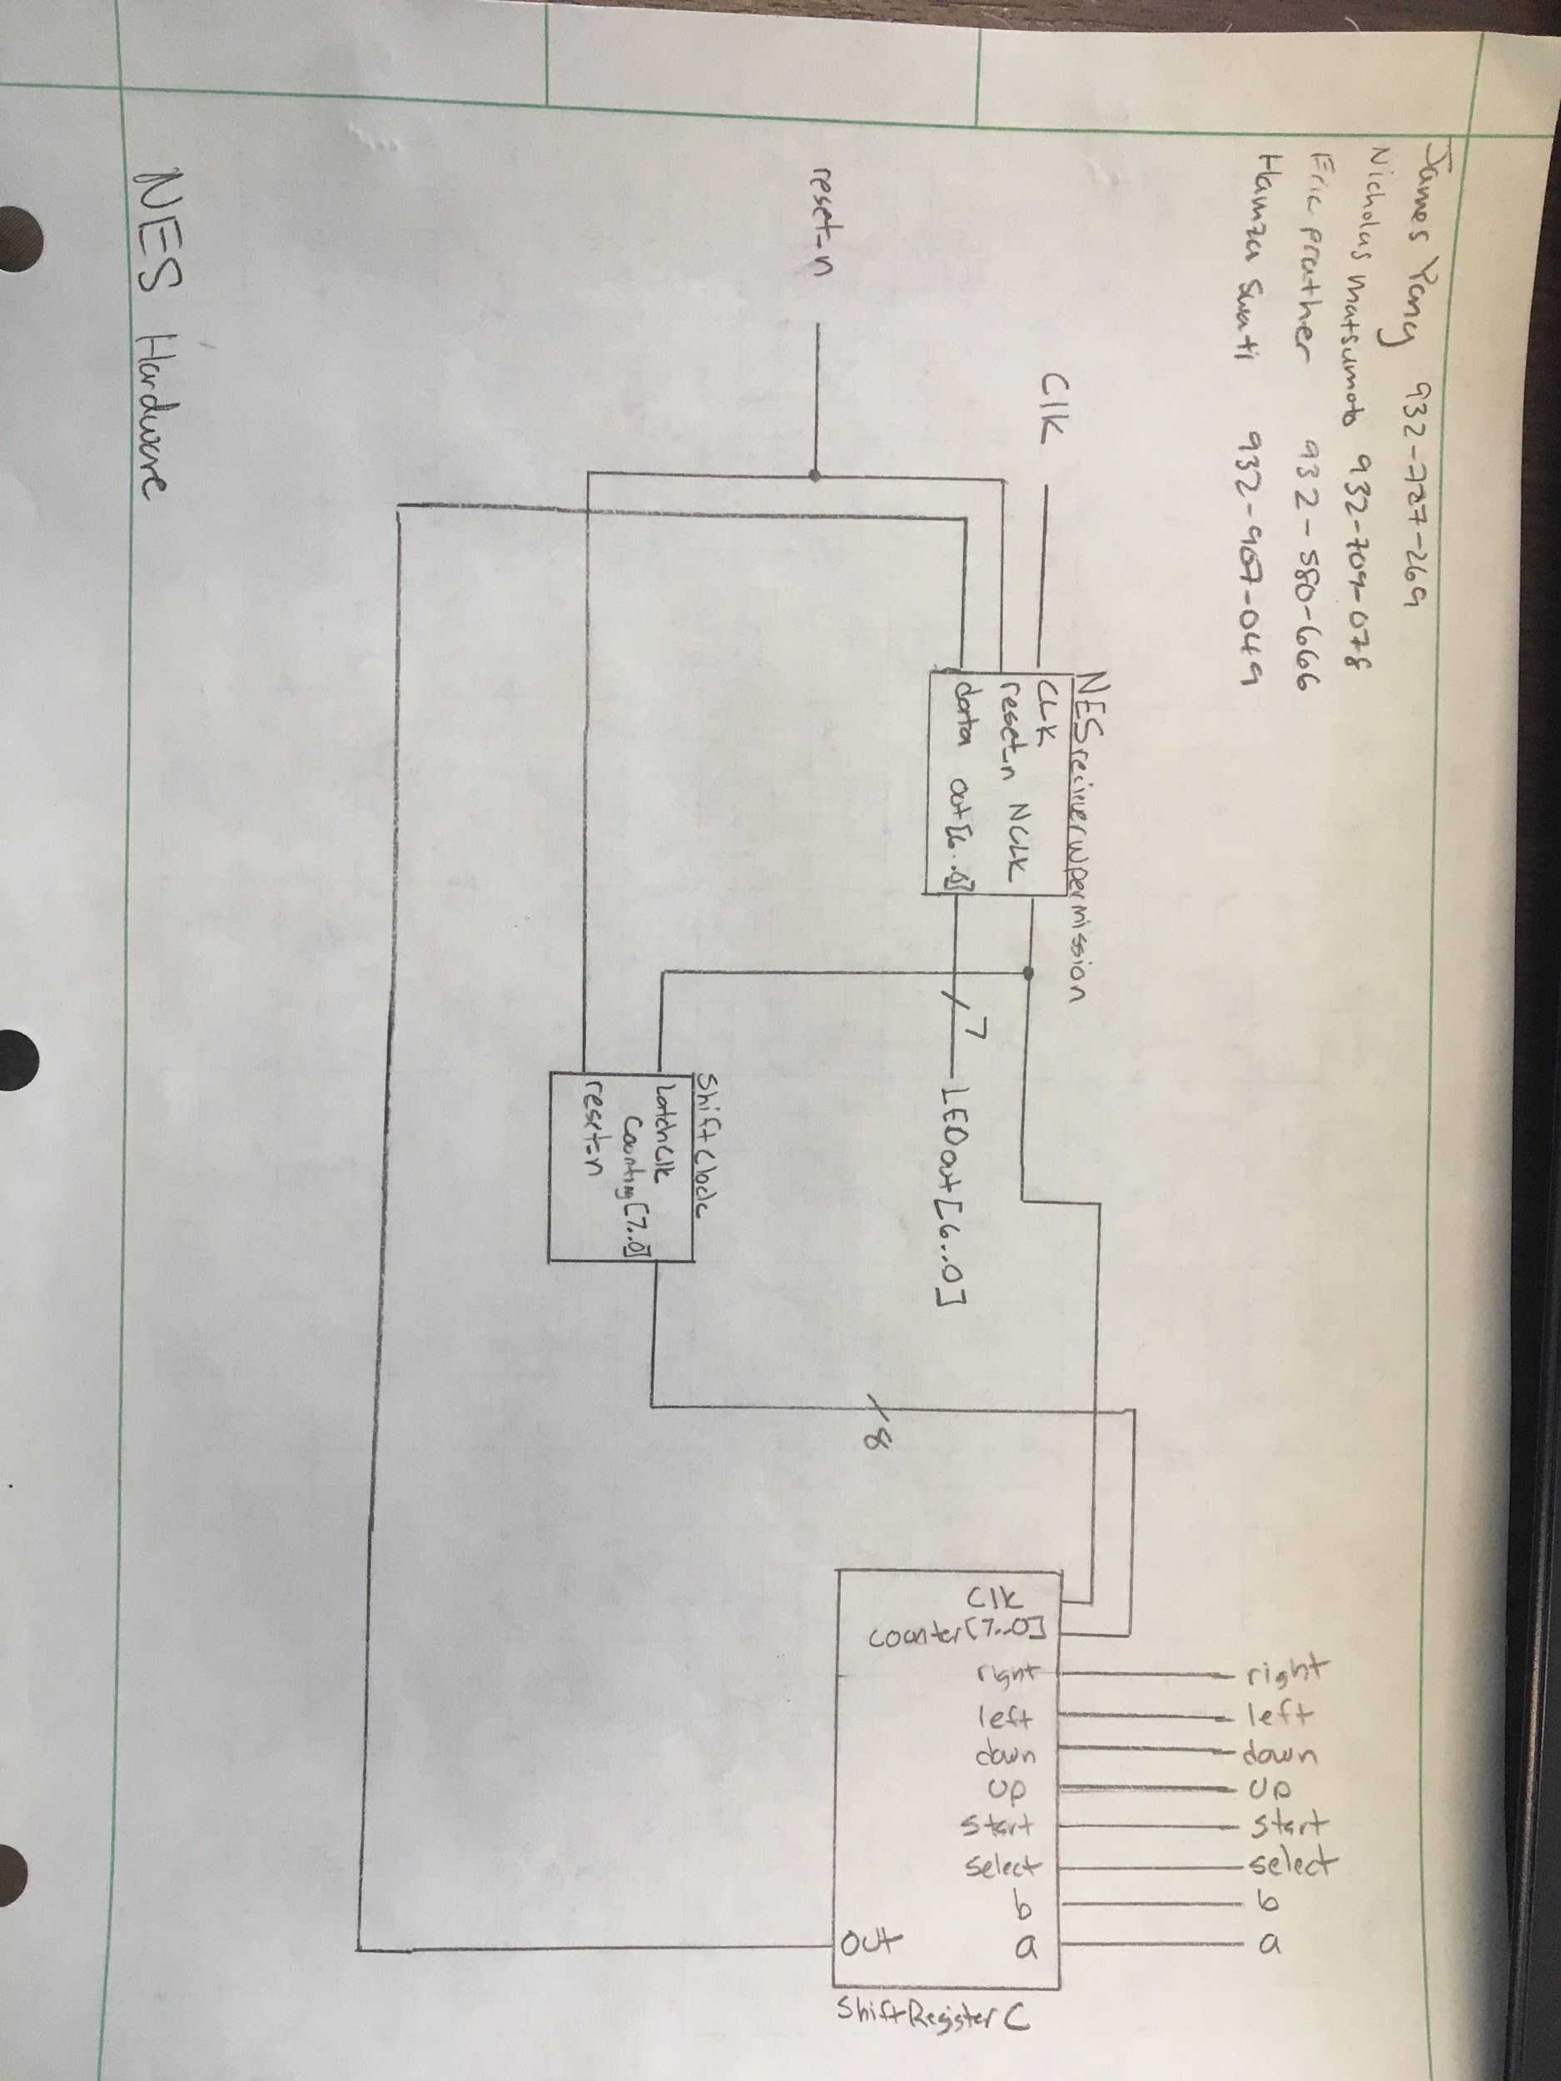

**FIgure 1.7: Hardware diagram of the NES controller.**

## PC/2 Hardware Diagrams

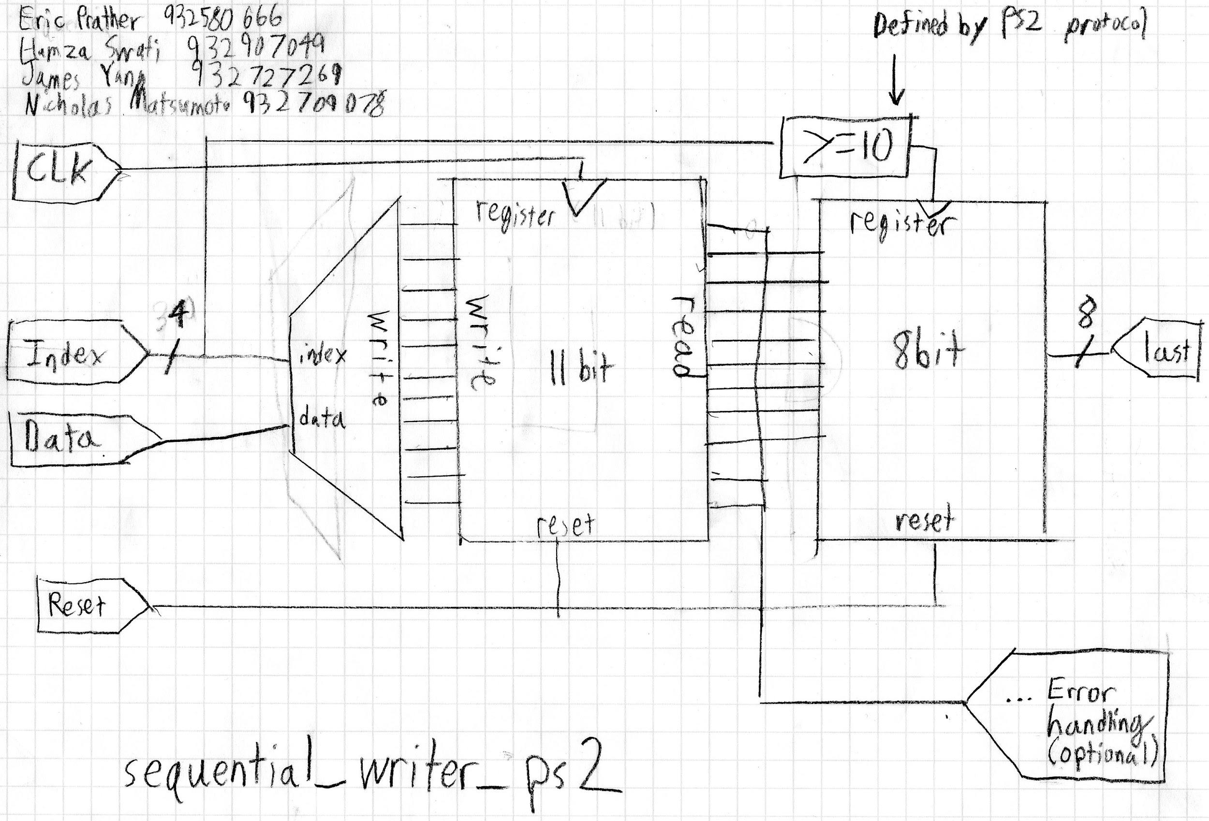

**Figure 1.8: sequential_writer_ps2 module diagram**

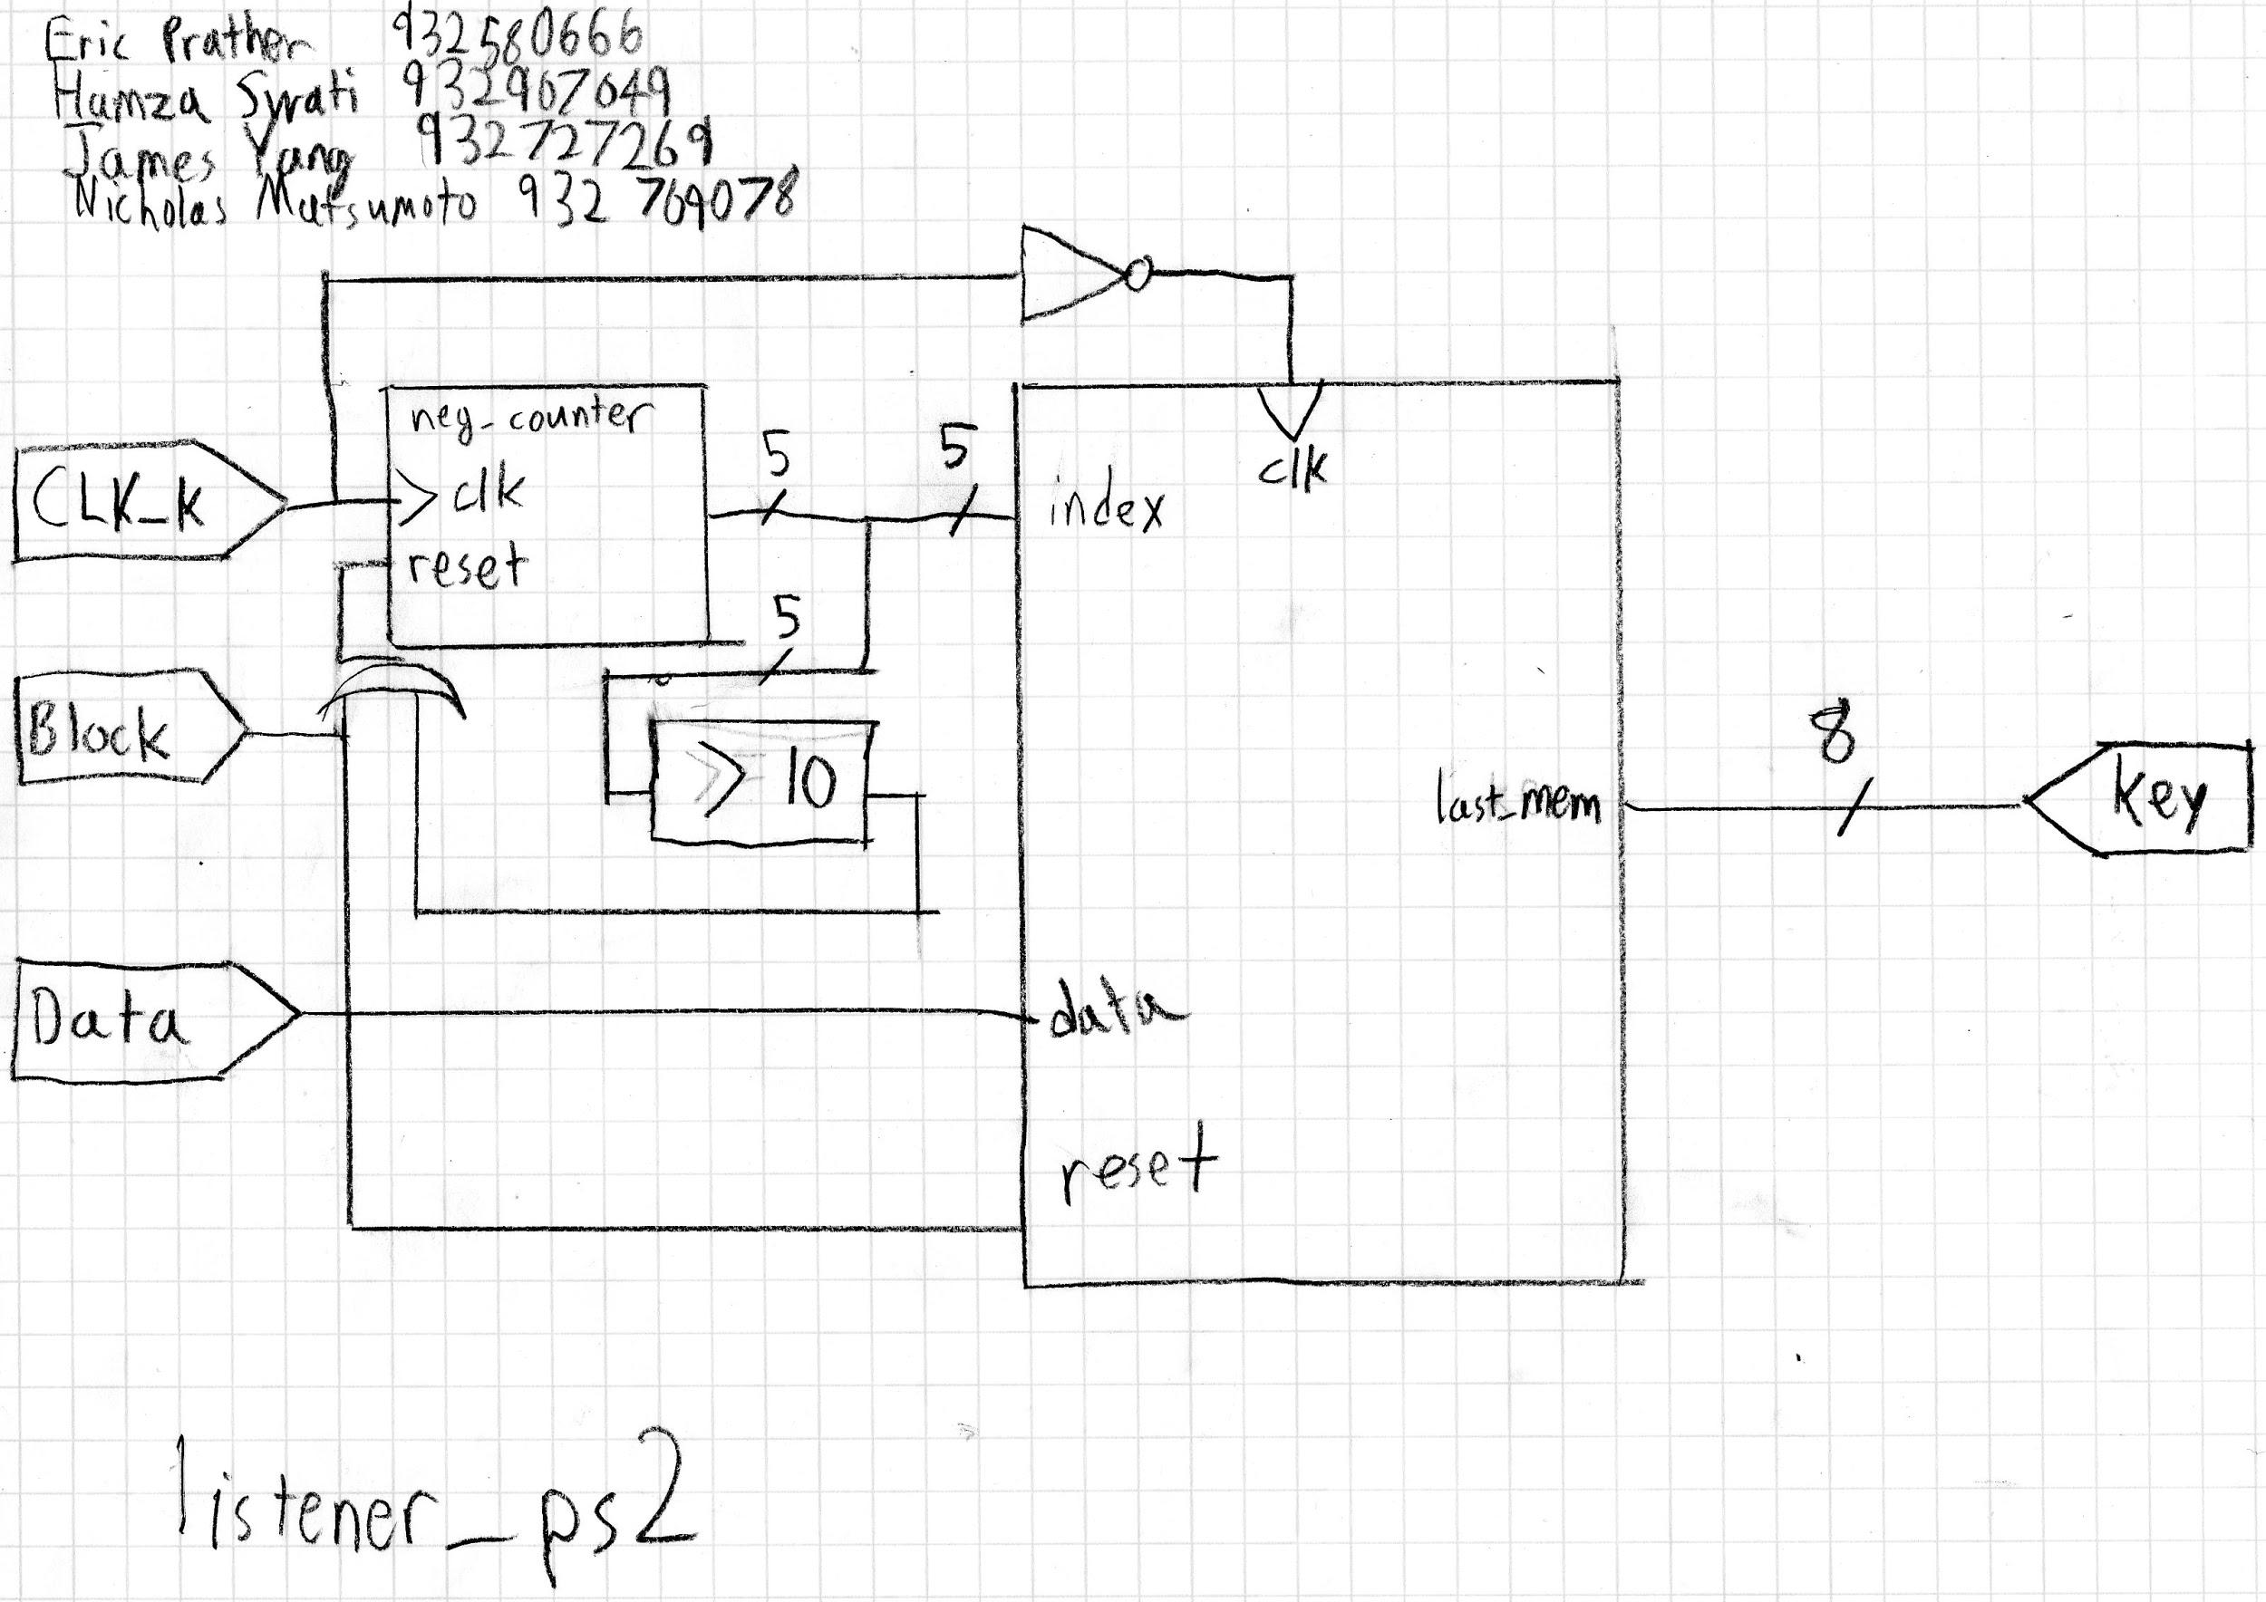

**Figure 1.9: listener_ps2 module diagram**

# 

# Functional Unit Tests

### NES Input A

This shows that input A in logic low (meaning active), and the seven segment output displays A being active as 1. The output correlates with the input, resulting in a successful simulation in our SystemVerilog.

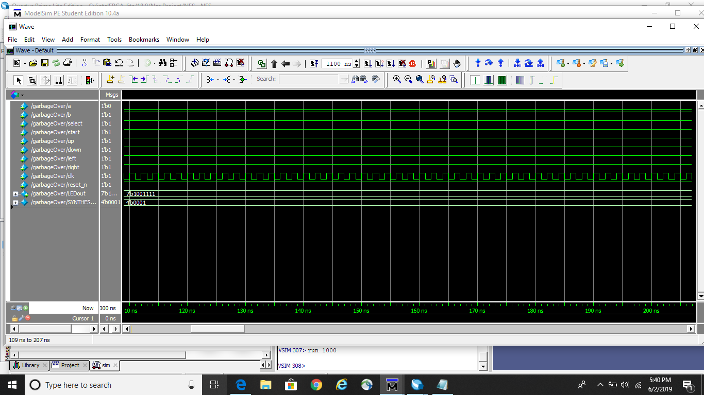

### NES Input B

This shows that input B in logic low (meaning active), and the seven segment output displays B being active as 2. The output correlates with the input, resulting in a successful simulation in our SystemVerilog.

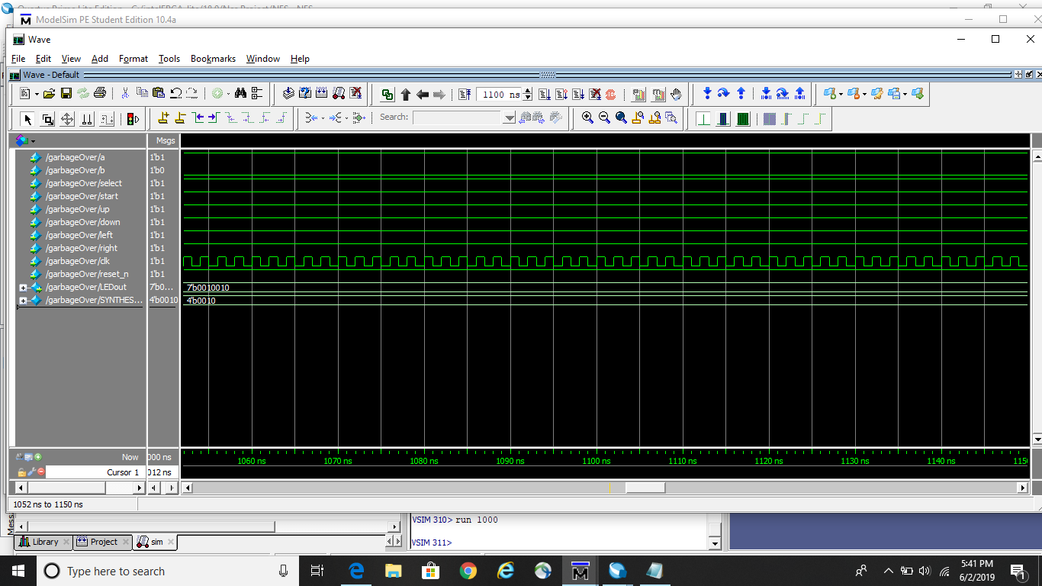

### NES Input Select

This shows that input select in logic low (meaning active), and the seven segment output displays Select being active as 3. The output correlates with the input, resulting in a successful simulation in our SystemVerilog.

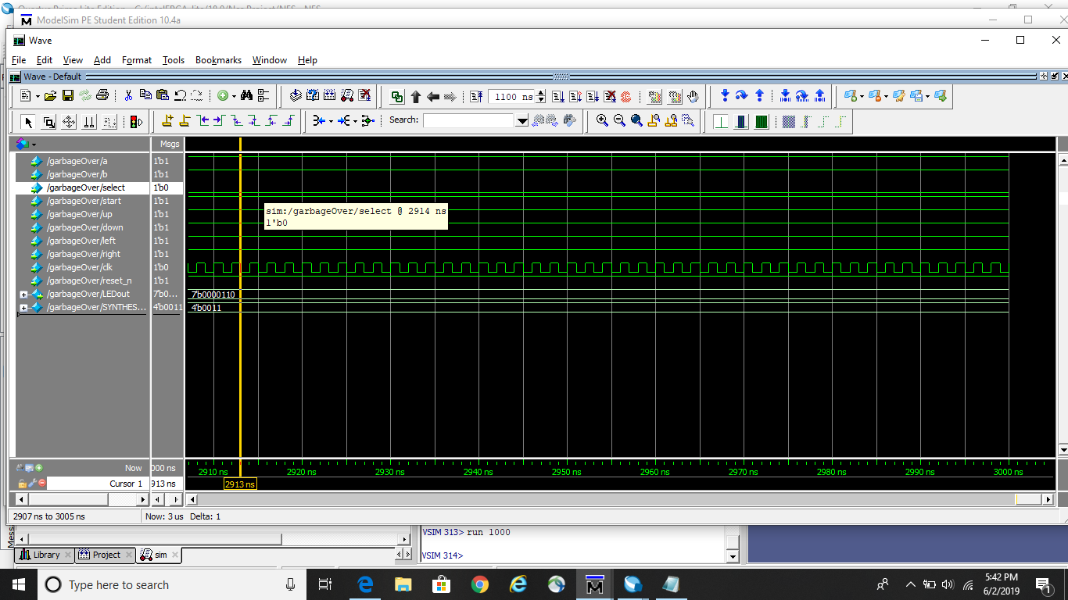

### NES Input Start

This shows that input Start in logic low (meaning active), and the seven segment output displays Start being active as 4. The output correlates with the input, resulting in a successful simulation in our SystemVerilog.

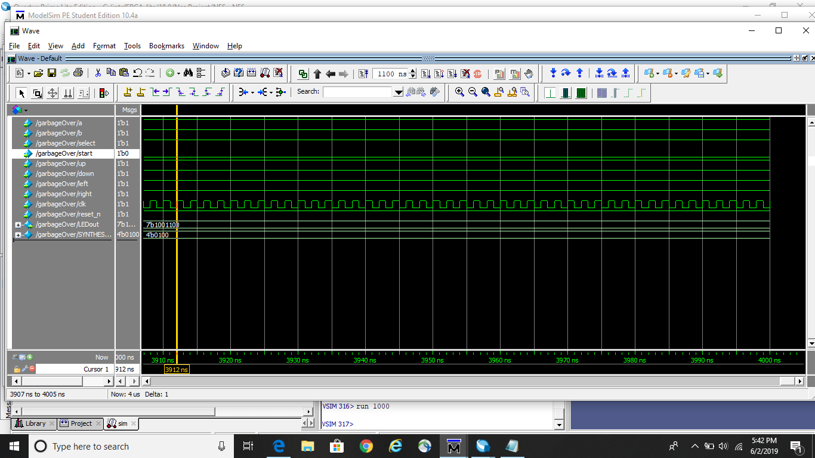

### NES Input Up

This shows that input up in logic low (meaning active), and the seven segment output displays up being active as 5. The output correlates with the input, resulting in a successful simulation in our SystemVerilog.

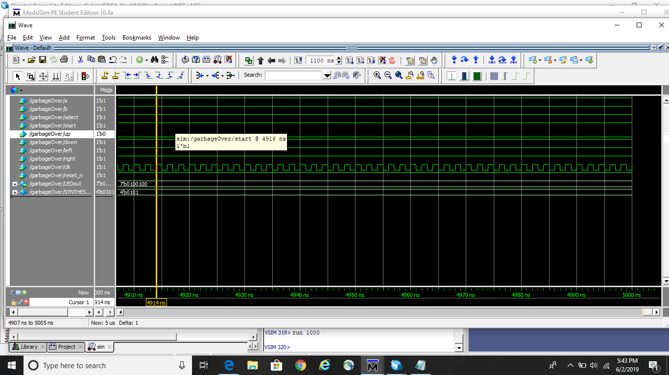

### NES Input Down

This shows that input Down in logic low (meaning active), and the seven segment output displays Down being active as 6. The output correlates with the input, resulting in a successful simulation in our SystemVerilog.



### NES Input Left

This shows that input Left in logic low (meaning active), and the seven segment output displays Left being active as 7. The output correlates with the input, resulting in a successful simulation in our SystemVerilog.

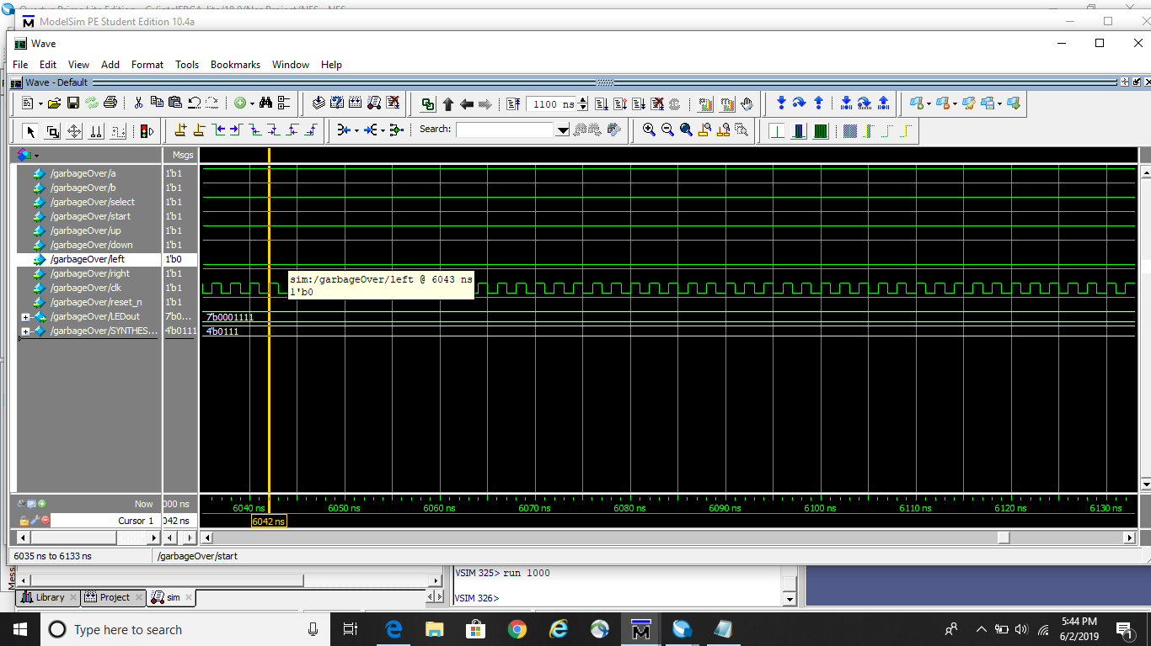

### NES Input Right

This shows that input Right low (meaning active), and the seven segment output displays Right being active as 8. The output correlates with the input, resulting in a successful simulation in our SystemVerilog.

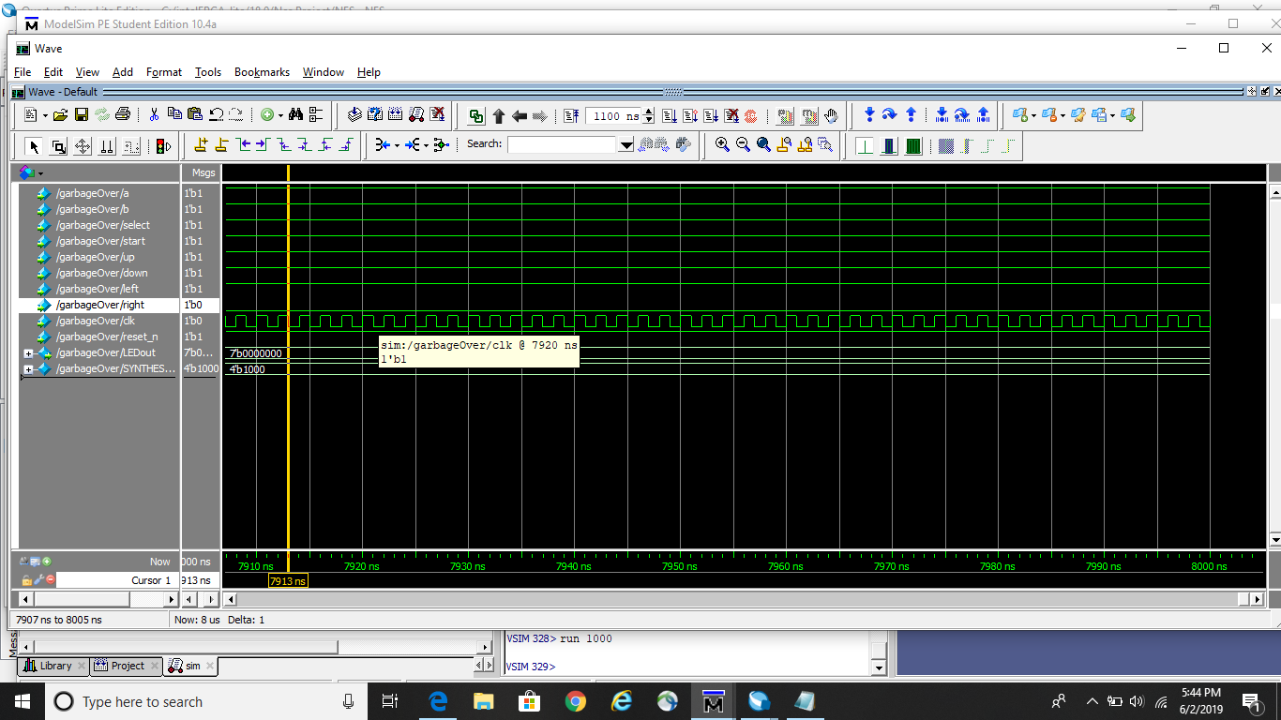

# Individual Block Tests

*Individual blocks would be counters, blocks of combinational logic, state machines, decoders, or other System Verilog modules.*

These can be inserted at leisure, whether during the process of development or at the very end. Notably, it is likely important both to include modelsim screenshots of each block test **accompanied by** general descriptions of the output.

Deprecated blocks, as well as blocks which do not appear in the final design, are not included in this section for the sake of clarity and conciseness.

### Switch

This ModelSim output demonstrates the mutual exclusivity of the outputs (enabler) based on **all possible** inputs. The behavior is consistent and distinct among all inputs, with the bus index of the high output corresponding to the unsigned value of the input number.

### Maximized Counter



This is a simple clock-based counter; the q value can be seen incrementing alongside the clock. The only notable unique element of this module is that it resets between a and 0 automatically, based on the MAX parameter.

### Hexadecimal Notation Shift Register C

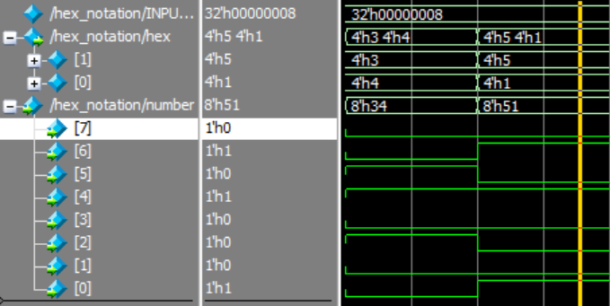

Here, it is tested with two hexadecimal values. As modelsim renders numerical values in hexadecimal, this is easier to see in the waveform. Simply observe the digits in the “number” wave, and then see them split into two separate entities in the “hex” bus.

### Sequential Writer

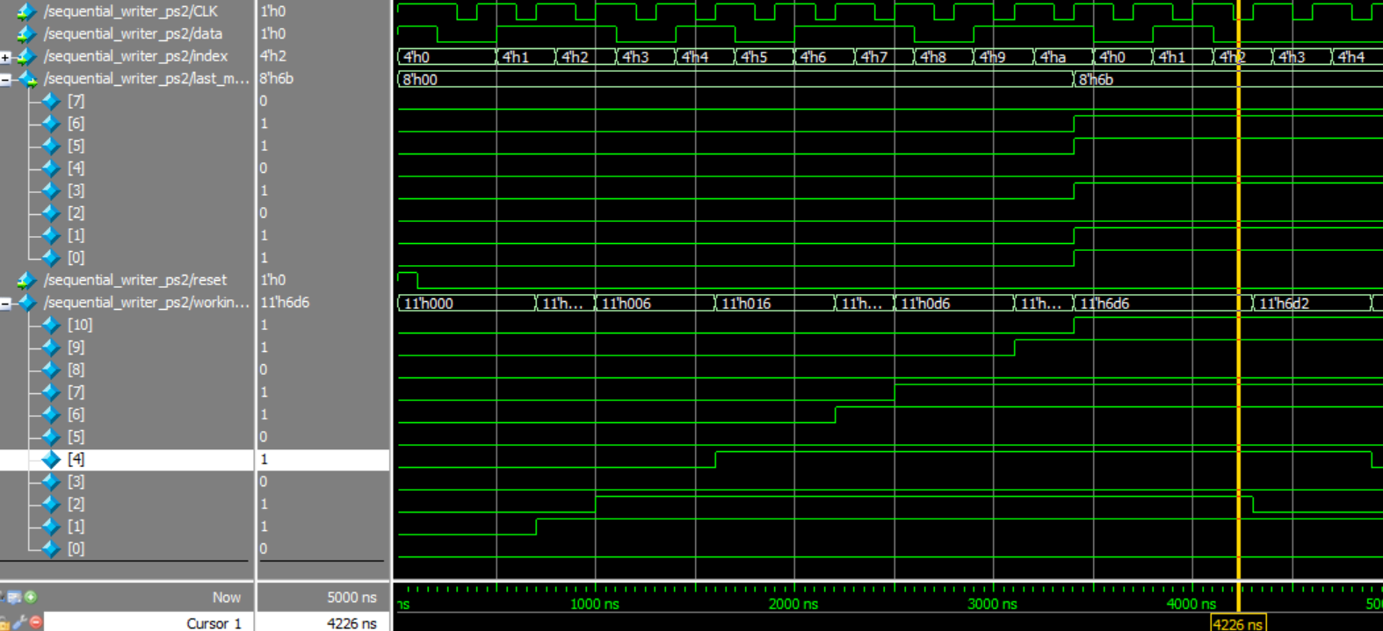

The simulation for the verification of the sequential writer module was very lengthy, as several features needed to be tested. In this simulation, a macro was compiled to simulate the behavior of a keyboard entering a little bit more data than is necessary for a keystroke to verify that the output is not interfered with by the next incoming stream of data. In the above diagram, the system starts in the reset state and then proceeds to immediately start sending data. As is visible in the bottom 11 rows, each bit is written to the working memory individually as it is received from the device, robust against timing irregularities. Also notice that data is read on the **falling edge** of the clock, a unique property of the PS/2 mouse/keyboard combination. Lastly, notice the presence of leading and ending bits; start and stop bits as well as a parity bit. In this example, these bits are correct, and are not reflected in the final output since they are not relevant to the specific keystroke recorded. In this case, the output is 107 (ASCII capital G).

The macro for this block was especially complex as the index had to be incremented manually. In the final system, this is not the case; see the documentation regarding listener_ps2.

### Sequential Listener

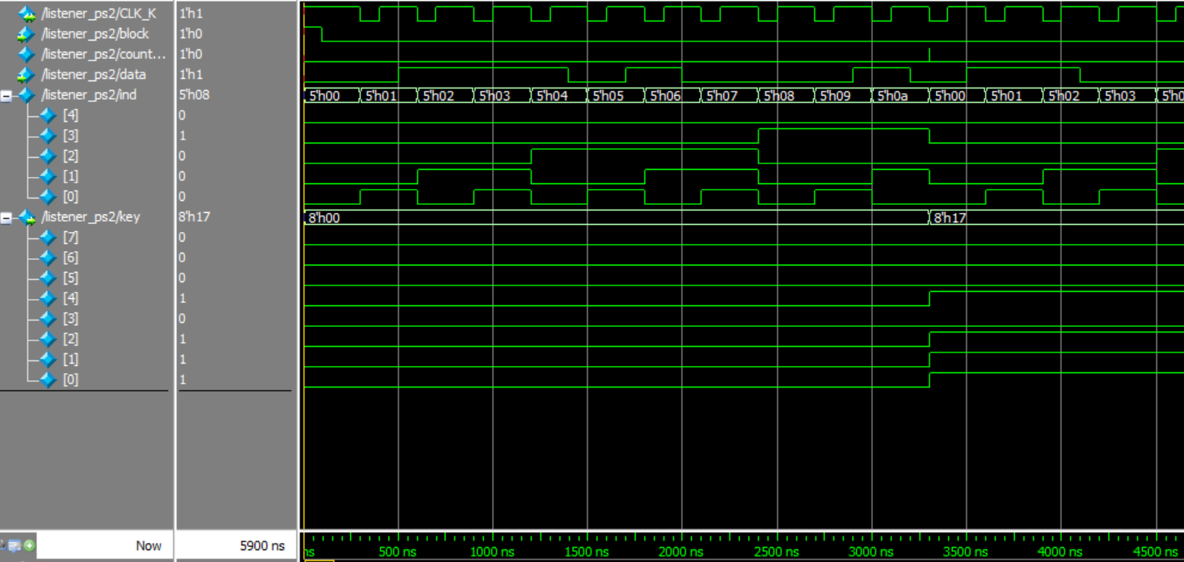

The above diagram implements the behavior of sequential writer to minimize the required input of the system to include only the input pins of the PS/2 port and the reset switch. Notably, in this example, the counter is exposed (note its operation on the **negative edge** of the clock), but the internal memory of the sequential writer (sequential_writer_ps2) is hidden. The only output element this module is concerned with is the keystroke recorded by the sequential listener coaxed by the data stream and counter; in this case, value 23 (ASCII ETB). As in the sequential writer example, extra data is fed to the simulation to ensure that it terminates properly.

Another notable behavior demonstrated here is the wrapping of index back to 0 after the output is written to key.

### NES Shift Register C

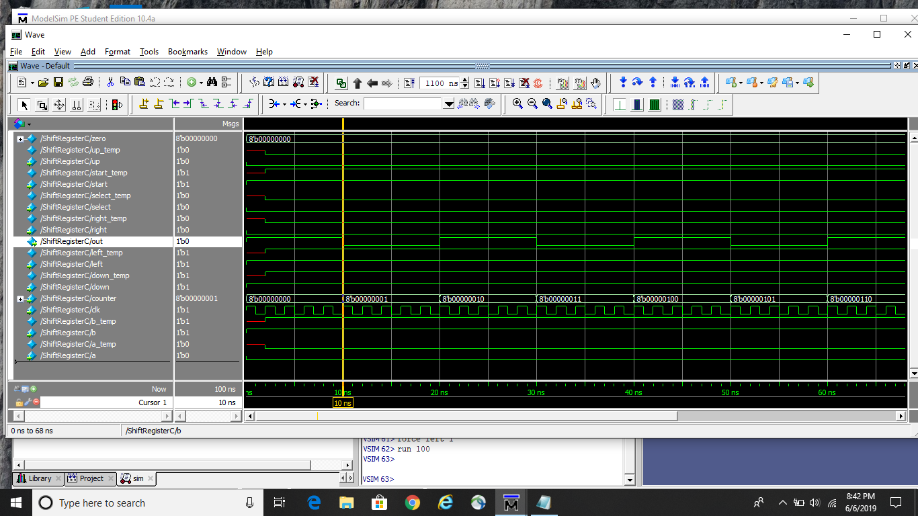

The above simulation shows behavior of a parallel in and serial out shift register. The shift register forgoes the normal load input in favor of automatically loading when the counter input is zero. The inputs for the simulation were alternated between high and low to show the timing and accuracy of the output. The output, out is changing at not only the correct clock time, but also when the counter changes. This is important because each value of the counter corresponds to an input on the NES controller

### NES Shift Clock

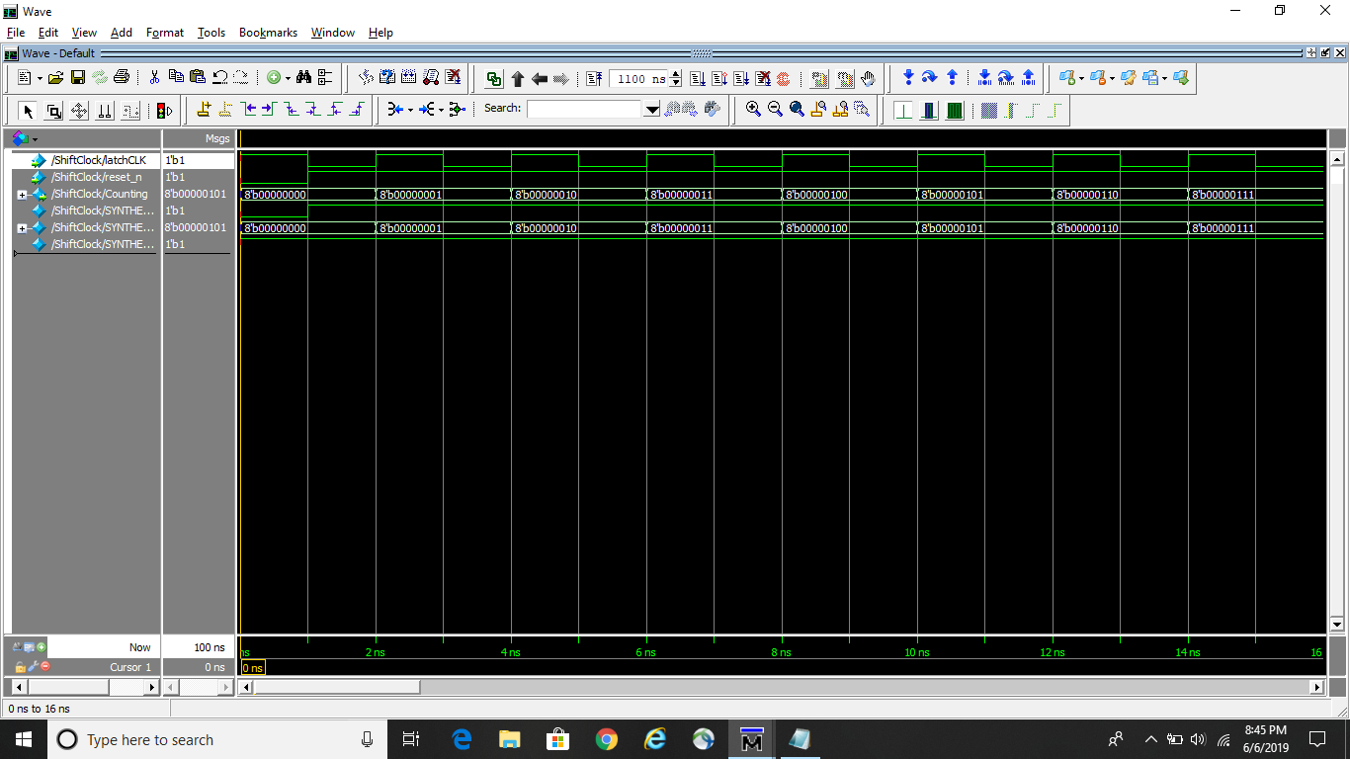

The shift clock module cycles in between 0 and 8 based on a clock signal. This module is meant to provide a value for the NES Register module. Furthermore, the module has a logic low reset so that the module can be properly synced with the others.

### NES Receiver

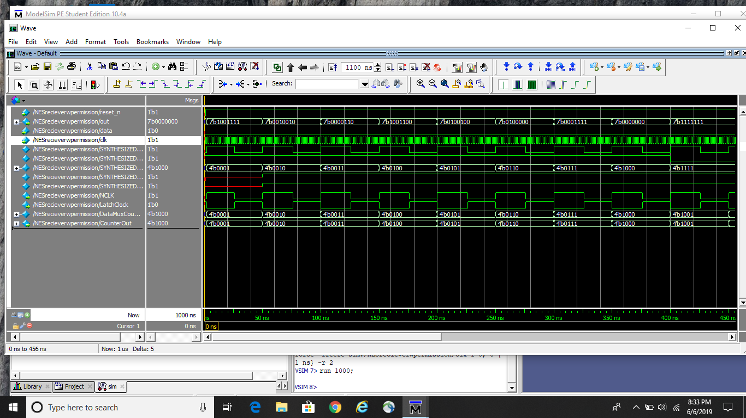

The NES receiver module takes a clock signal and based on the data signal decides what number to output to the LED. This simulation held data to a logic low which displayed all the LED signals changing from 1 to 8 based on a clock signal. When the LED output displays nothing that signifies that either the data input was at a logic high or that the module is on the clock cycle that corresponds to the load time of the shift register.

# Documentation

All system verilog code documentation may be viewed at a higher level here. For graphical representations of this outline, please see Top Level Diagram and Hardware Diagram. For the validation of these systems and simulation data, please see Functional Unit Tests and Individual Block Tests.

## Top Layer

### PS/2 System Specification

This system is to interface with several input devices and provide their output in a discrete, easily readable numerical form. As an extension upon this core principle, this output should be rendered both on an onboard 7-segment display and in terms of color on a VGA monitor. The color will be determined by the hash value of the raw input provided by either supported device.

### NES System Specification

This system is meant to interface with an NES controller and output a number representing one of the eight NES controller inputs on the seven segment display.

## Functional Units

On this layer, the constituent elements of the driver are combined and connected in such a way so as to synthesize useful behaviors.

### Listener

**Module**: listener_ps2

**Description**: Although a circuit might wish to transfer many streams of data in parallel, this protocol only has one pin for data transmission. As such, data which is received in *parallel* must be inputted as a single, *very* short period string of binary values. Each string of bits is a byte plus a couple of serial and control bits; hence, there are only 2^8 possible outputs for this module. It contains a register to buffer the input and a register to store the output when the stop signal is received.

This module has no functionality for host to device communication, as it was not defined in the system specification and would present a vulnerability for abuse depending on the application of the protocol. However, were such a feature to be desired, a location in this module’s code is specified for the insertion of an interrupt behavior on CLK_K: See [Chapweske 1999](http://www.burtonsys.com/ps2_chapweske.htm).

**I/O and Parameters**:

|  |  |  |  |
| --- | --- | --- | --- |
| **Name** | **Class** | **Data Type** | **Description** |
| block | input | logic | Control to pause input from the keyboard on high. |
| data | input | logic | The current state of the data stream from the PC2 controller. |
| CLK_K | inout | logic | Signal from the keyboard that the next bit has been transmitted and should be recorded. |
| key | output | logic[7:0] | The last successfully recorded keystroke. |

### Sequential Writer

**Module**: sequential_writer_ps2

**Description**: This module reads sequential streamed binary data as per the ps2 standard. In the current implementation there is no error handling since this system has no defined error behavior- however, a location is identified for the verification of parity, start, and stop bits so as to add an error channel.

**I/O and Parameters**:

|  |  |  |  |
| --- | --- | --- | --- |
| **Name** | **Class** | **Data Type** | **Description** |
| index | input | logic | The bit in working memory which data currently corresponds to. |
| CLK | input | logic | The signal which triggers the writing of data to index in working memory. Positive edge firing. |
| data | input | logic | A binary value from the streamed data. |
| reset | input | logic | A signal which resets working and output memory. |
| last_mem | output | logic [7:0] | The last fully correct PS/2 stream received by this module. |

## Individual blocks

This layer is where the core, simplified parts of the system are considered. The overall driver is interpreted here in terms of its constituent elements.

### Selection Switch

**Module**: selN

**Description**: Functions equivalently to a decoder, designed from scratch and parameterized for system expandability. Extra functionality is added for development convenience.

**I/O and Parameters**:

|  |  |  |  |
| --- | --- | --- | --- |
| **Name** | **Class** | **Data Type** | **Description** |
| BITS | Param | uint | The number of bits to be used to store possible inputs and outputs |
| select | Input | logic [BITS - 1:0] | The control for the switch behavior of the block. This |
| enabler | Output | logic [2 ** BITS - 1:0] | A bus with mutually exclusive wires. |

### Counter

**Module**: counter

**Description**: Counts from 0 to 2^(N-1). Overflows appropriately to 0.

**I/O and Parameters**:

|  |  |  |  |
| --- | --- | --- | --- |
| **Name** | **Class** | **Data Type** | **Description** |
| N | param | integer | The number of bits of memory for the counted number. |
| clk | input | logic | The clock which increments the counted number on the rising edge |
| reset | input | logic | A value which, being recieved, set’s the counter’s memory to 0 and prevents incrementing. |
| q | output | Logic [N-1:0] | The current number contained in the counter, always incrementing one at a time or resetting to 0. |

### Maximized Counter

**Module**: counter_max

**Description**: Counts from 0 to 2^(N-1). Overflows appropriately to 0 at a value determined at instantiation.

**I/O and Parameters**:

|  |  |  |  |
| --- | --- | --- | --- |
| **Name** | **Class** | **Data Type** | **Description** |
| N | param | integer | The number of bits of memory for the counted number. |
| MAX | param | integer | The maximum number the counter may reach before being forced to reset to 0. |
| clk | input | logic | The clock which increments the counted number on the rising edge |
| reset | input | logic | A value which, being recieved, set’s the counter’s memory to 0 and prevents incrementing. |
| q | output | Logic [N-1:0] | The current number contained in the counter, always incrementing one at a time or resetting to 0. |

### Negated Counter

**Module**: counter

**Description**: Behaves identically to counter, except uses the **negative** edge of the clock instead of the **positive** edge.

**Warning**: This module is deprecated. Please use counter instead, piping the inverse of the clock signal into the clk input.

**I/O and Parameters**:

|  |  |  |  |
| --- | --- | --- | --- |
| **Name** | **Class** | **Data Type** | **Description** |
| N | param | integer | The number of bits of memory for the counted number. |
| clk | input | logic | The clock which increments the counted number on the falling edge |
| reset | input | logic | A value which, being received, set’s the counter’s memory to 0 and prevents incrementing. |
| q | output | Logic [N-1:0] | The current number contained in the counter, always incrementing one at a time or resetting to 0. |

### Negated Maximized Counter

**Module**: counter_max

**Description**: Counts from 0 to 2^(N-1). Overflows appropriately to 0 at a value determined at instantiation. Uses the negative edge of the clock instead of the positive edge

**Warning**: This module is deprecated. Please use counter_max instead, piping the inverse of the clock signal into the clk input.

**I/O and Parameters**:

|  |  |  |  |
| --- | --- | --- | --- |
| **Name** | **Class** | **Data Type** | **Description** |
| N | param | integer | The number of bits of memory for the counted number. |
| MAX | param | integer | The maximum number the counter may reach before being forced to reset to 0. |
| clk | input | logic | The clock which increments the counted number on the falling edge |
| reset | input | logic | A value which, being received, set’s the counter’s memory to 0 and prevents incrementing. |
| q | output | Logic [N-1:0] | The current number contained in the counter, always incrementing one at a time or resetting to 0. |

### 

### Hexadecimal Notation

**Module**: hex_notation

**Description**: Breaks any given very long unsigned integer into hexadecimal notation. Purely combinatorial logic. This is especially useful in driving the 7 segment display drivers from labs 2 and 5 respectively; but may also be relevant to the VGA driver, depending on the intended implementation.

**I/O and Parameters**:

|  |  |  |  |
| --- | --- | --- | --- |
| **Name** | **Class** | **Data Type** | **Description** |
| INPUT_SIZE | param | int | The number of bits the inputted number is to have. |
| number | input | Logic [INPUT_SIZE-1:0] | The plain number to be broken into hexadecimal digits |
| hex | output | Logic [(INPUT_SIZE/4)-1:0][3:0] | A bus of hexadecimal digits; this is analogous to a nested array in terms of operators. These hexadecimal digits are derived from the input number combinatorially and are ordered from least to most significant. |

### NES Clock Holder

**Module**: ClockHolder

**Description**: Has a counter that begins to count, making the output logic high when the count is less than 12 and logic low when the count is greater than 11, and resetting at the count time of 24 seconds. It repeats this cycle unless the input has a logic high on reset.

**I/O and Parameters**:

|  |  |  |  |
| --- | --- | --- | --- |
| **Name** | **Class** | **Data Type** | **Description** |
| clk | input | clk | Clk input 10 Mhz |
| reset | input | int | Resets the clock at logic high and does nothing at logic low. |
| q | output | int | Returns either logic high or logic low depending on whether the input is logic low on reset and the clk input is running at a certain time. |

### NES Counter

**Module**: counter

**Description**: contains the always_ff that has the clock on the positive edge and the negative edge for the reset. The input of the clock continues and is active low for the reset.

**I/O and Parameters**:

|  |  |  |  |
| --- | --- | --- | --- |
| **Name** | **Class** | **Data Type** | **Description** |
| clk | input | clk | Clk input 10 Mhz |
| reset | input | int | Resets the clock at logic high and does nothing at logic low. |
| q | output | int | Outputs a 4 bit value from the counter. |

### NES Data Mux

**Module**: DataMux

**Description**: Contains an if statement that outputs the value 4’b1111 if the input for data is logic high, otherwise it outputs the exact input.

**I/O and Parameters**:

|  |  |  |  |
| --- | --- | --- | --- |
| **Name** | **Class** | **Data Type** | **Description** |
| data | input | int | Input from the previous module that determines the output value. |
| counterInput | input | int | 4 bit input from the counter’s output. |
| out | output | int | Outputs a 4 bit value. |

### NES Greater Comparator

**Module**: GreaterComparator

**Description**: Takes in an 8 bit value and compares the value of A with 10 and decides whether the output should be a logic high or logic low.

**I/O and Parameters**:

|  |  |  |  |
| --- | --- | --- | --- |
| **Name** | **Class** | **Data Type** | **Description** |
| a | input | int | Value from the previous module that inputs into the comparator to decipher whether the value is greater than or less than 10 |
| gt | output | int | Outputting 1 depending on whether the input is greater than or less than 10. |

### NES Latch Counter

**Module**: latchCounter

**Description**: always_ff with a negative edge clock and a negative edge reset. It returns the output bit size of 8 depending on the size of the input and whether the logic of reset is high or low.

**I/O and Parameters**:

|  |  |  |  |
| --- | --- | --- | --- |
| **Name** | **Class** | **Data Type** | **Description** |
| clk | input | clk | Clk input 10 Mhz |
| reset | input | int | Resets the clock at logic high and does nothing at logic low. |
| q | output | int | Outputs an 8 bit value. |

### NES Lesser Comparator

**Module**: LesserComparator

**Description**: The exact same module as the Greater Comparator except with a less than.

**I/O and Parameters**:

|  |  |  |  |
| --- | --- | --- | --- |
| **Name** | **Class** | **Data Type** | **Description** |
| a | input | clk | Clk input 10 Mhz |
| lt | output | int | Outputs an 8 bit value depending on if a < 10 |

### NES Lesser Equal Comparator

**Module**: LesserEqualComparator

**Description**: The exact same module for Greater Comparator except with a == to 10

**I/O and Parameters**:

|  |  |  |  |
| --- | --- | --- | --- |
| **Name** | **Class** | **Data Type** | **Description** |
| a | input | clk | Clk input 10 Mhz |
| lt | output | int | Outputs an 8 bit value depending on if a == b. |

### NES Load Handler

**Module**: loadHandler

**Description**: Essentially sets the loadsignal to 0 regardless of the combination just to force the value out.

**I/O and Parameters**:

|  |  |  |  |
| --- | --- | --- | --- |
| **Name** | **Class** | **Data Type** | **Description** |
| count | input | int | 8-bit input counter. |
| loadSignal | output | int | Outputs 0 regardless of input. |

### NES Shift Register

**Module**: ShiftRegisterC

**Description**: The shift register takes the input variables and setting them equal to temporary variables, then outputting based off the clock.

**I/O and Parameters**:

|  |  |  |  |
| --- | --- | --- | --- |
| **Name** | **Class** | **Data Type** | **Description** |
| a | input | int | Input A for the shift register |
| b | input | int | Input B for the shift register |
| select | input | int | Input select for the shift register |
| start | input | int | Input start for the shift register |
| up | input | int | Input up for the shift register |
| down | input | int | Input down for the shift register |
| left | input | int | Input left for the shift register |
| right | input | int | Input right for the shift register |
| counter | input | int | Input counter for the shift register |
| clk | input | int | Input clk for the shift register |
| out | output | int | Output logic after setting temporary variables in an 8 bit form. |

# Extra Feature: Graphical Synthesis of a Hash Function on an FGPA

*Added a good extra feature (maybe a macro button, or including the VGA driver)? (2 points extra credit)*

This is not mandatory, but it is included here for the sake of completeness. These extra credit points seem significantly easier to obtain than the ones which come from undertaking harder projects. It should take no more than five minutes to integrate a switch which toggles between this design project and the VGA driver which is to be built in lab anyway.

The extra feature of this project is a **non-continuous hash function** which takes keys from any arbitrary controller from the input device driver and outputs a hash code, which is later interpreted by the ECE 272 Lab 6 VGA color to display a graphical representation of the hash on the screen. This graphical representation of a hash function output because it demonstrates the properties of **determinism**, **uniformity**, and **non-continuity**.

The hash function we selected has several famous constants related to 8 bit cryptographic hash functions, as is evident in the code. Notably, this operation is irreducibly complex and serial, meaning that the time the hash function requires to complete ranges in complexity between O(1) and O(n^2), even taking full advantage of the parallel processing capabilities of the FPGA.

### Color Hash

**Module**: chash

**Description**: Generates a 32 bit non-continuous hash index from any arbitrary index. This is not cryptographically secure.

**I/O and Parameters**:

|  |  |  |  |
| --- | --- | --- | --- |
| **Name** | **Class** | **Data Type** | **Description** |
| HASH_BASE | parameter | int | 5381; famous constant- starting hash |
| MULT | parameter | int | 31; famous constant- incremental hash multiplier |
| KEY_SIZE | parameter | int | The size of the key, in bit |
| key | input | logic[KEY_SIZE-1:0] | Any arbitrary key to be transformed into a hash value. |
| hash | output | Logic [31:0] | The hash code of the key. |

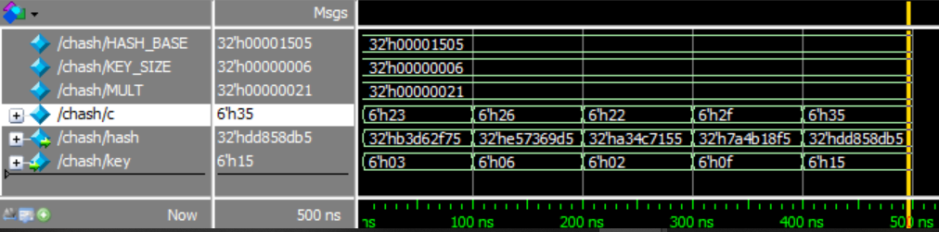

This simulation demonstrates the non-continuity of the hash function. This output is plugged directly into the driver from lab 6, whose summary is as follows:

### VGA Driver

**Module**: monitor

**Description**: Prints pixel data to a monitor.

**I/O and Parameters**:

|  |  |  |  |
| --- | --- | --- | --- |
| **Name** | **Class** | **Data Type** | **Description** |
| reset | input | logic | tin |
| sys_clk | input | logic | A 50MHz **exactly** clock. |
| c_switches | input | logic[5:0] | An value used to drive RGB. The least significant two digits are red, the middle digits are green, and the last digits are blue |
| hsync | output | logic | Horizontal sync wave as per VGA protocol |
| vsync | output | logic | Vertical sync wave as per VGA protocol |
| red | output | logic [3:0] | The color to display on the monitor in terms of its red proportion. |
| green | output | logic [3:0] | The color to display on the monitor in terms of its green proportion. |
| blue | output | logic [3:0] | The color to display on the monitor in terms of its blue proportion. |

The code for the driver, as well as the hash function, can be found in the appendix.

# Appendix A: System Verilog Code

## NES ClockHolder.sv

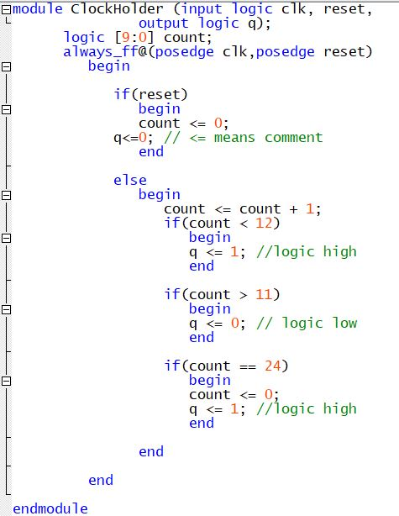

## counter.sv

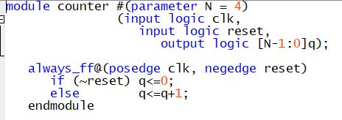

## NES DataMux.sv

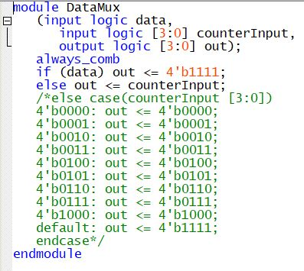

## NES GreaterComparator.sv

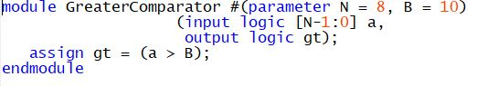

## NES latchCounter.sv

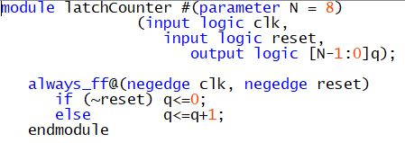

## NES LesserComparator.sv

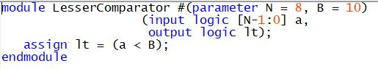

## NES LesserEqualComparator.sv

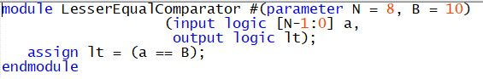

## NES loadHandler.sv

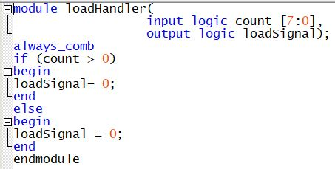

## NES ShiftRegisterC.sv

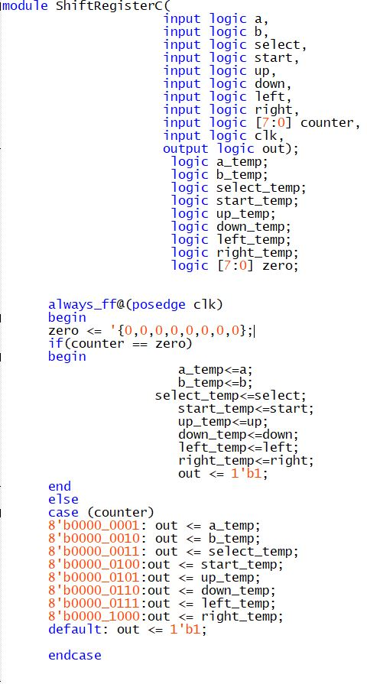

## ops.sv

//ops.sv

// This file contains very simple, low level functions which are

// imperative to the driver's operation.

// This functions as a simple, various-bit decoder.

// Note that the "a ** b" operation is "a to the power of b"

// BITS: The number of bits to be used for possible states

// select: A binary number representing which output channel should be logic high.

// enabler: A bus wherein only one output is high at any point, based on select.

module switch #(parameter BITS = 2)

(input logic [BITS-1:0] select, output logic [(2 ** BITS)-1:0] enabler);

always_comb begin //always_comb is best for comb. logic, not sure what the difference

//is between it and "always @ (*)"

for(int i = 0; i < 2 ** BITS; i++) begin

unique if(select == i) begin //"unique" means the true and false are mutually exclusive.

enabler[i] = 1;

end else begin

enabler[i] = 0;

end //end if

end //end for

end //end always

endmodule

//Counts from 0 to 2^(N-1). Overflows appropriately to 0.

//This module was used in lab 5.

//N: Number of bits of memory + 1

//clk: A signal which, upon reception, increments the counter.

//reset: A signal which, on reception, both sets the counter to zero and prevents clk.

//q: An unsinged integer which demonstrates the current state of the counter.

module counter #(parameter N = 4) (input logic clk, input logic reset, output logic [N-1:0]q);

always_ff@(posedge clk, posedge reset)

if(reset) q<= 0;

else q <= q+1;

endmodule

//Counts from 0 to 2^(N-1). Overflows appropriately to 0 upon reaching a value

// specified at instantiation time.

//N: Number of bits of memory + 1

//MAX: The maximum value this counter can reach before the next increment resets

// it to zero

//clk: A signal which, upon reception, increments the counter.

//reset: A signal which, on reception, both sets the counter to zero and prevents clk.

//q: An unsinged integer which demonstrates the current state of the counter.

module counter_max #(parameter N = 4, parameter MAX = 10) (input logic clk, input logic reset, output logic [N-1:0]q);

always_ff@(posedge clk, posedge reset)

if(reset | q == MAX) q<= 0;

else q <= q+1;

endmodule

//THIS MODULE IS DEPRECATED- see documentation. Do not delete it, it is used in core.sv

//Identical to counter except uses the negative edge of the clock

//In in hindsight, this could have been acheived by inverting the clk of the above when it

//is passed into the instance, but oh well; live and learn

module neg_counter #(parameter N = 4) (input logic clk, input logic reset, output logic [N-1:0]q);

always_ff@(negedge clk, posedge reset)

if(reset) q<= 0;

else q <= q+1;

endmodule

//THIS MODULE IS DEPRECATED- see documentation. Do not delete it, it is used in core.sv

//Identical to negative counter, but has the option to include an early overload.

//I bear the same concern with this module with respect to neg_counter

module neg_counter_max #(parameter N = 4, parameter MAX = 10) (input logic clk, input logic reset, output logic [N-1:0]q);

always_ff@(negedge clk, posedge reset)

if(reset | q == MAX) q<= 0;

else q <= q+1;

endmodule

// Converts an unsigned number into hexidecimal notation

// Here is a relevant URL for range notation in sv:

// https://forums.xilinx.com/t5/Design-Entry/Verilog-Loop-error-range-must-be-bounded-by-constant-expressions/td-p/721765

// Anyway, here are the details:

// INPUT_SIZE: The amount of bits of input. INPUT_SIZE % 4 MUST BE 0.

// number: The number to be broken into hexidecimal digits

// hex: A bus of hexidecimal digits, of size INPUT_SIZE/4. Ordered from

// least to most significant digits.

// NOTE- a hexidecimal digit is a 4 bit unsigned integer.

module hex_notation #(parameter INPUT_SIZE = 8)

(input logic [INPUT_SIZE-1:0] number, output logic [(INPUT_SIZE/4)-1:0][3:0] hex);

always_comb begin

for(int i = 0; i < (INPUT_SIZE/4); i++) begin

hex[i] = number[i*4 +: 4]; //This is a weird notation, see the url at the top

end

end

endmodule

## core.sv

// SIGNAL ORDER for PS/2:

// 1. Parity 0

// 2. Data * 8 (any)

// 3. Parity 1.

// 4. Stop 1.

// 5. Agknowledge (n/a)

module sequential_writer_ps2 (input logic [3:0] index, input logic CLK, input logic data, input logic reset, output logic [7:0] last_mem);

logic [10:0] working_mem;

//It may be preferrable to declock this function and instead be sensitive to index changing.

always_ff @(posedge CLK, posedge reset) begin

if(reset) begin

working_mem <= 0;

last_mem <= 0;

end else begin

working_mem[index] = data;

if(index >= 10) begin

// If you were to write error-checking code, it would be here.

// You would check the first bit and last two bits. If they were

// wrong, you would set the clock to low for 100us, flush

// working_mem, and reset.

last_mem <= working_mem[8: 1];

end

end

end

endmodule

// This takes all of the keyboard data possibilities and decodes them

// from binary transmission form (for one pin). This does not do any

// error handling.

// SIGNAL_BITS: The maximum number of bits which can be recieved from the device

// SIGNAL_LENGTH: The length of a completed signal.

// SURROUND_LENGTH: The number of bits of metadata surrounding the input.

// block: control for halting the current keyboard input.

// Data: The current signal from the keyboard

// CLK_K: Keyboard clock

// key: The last received ASCII character

module listener_ps2 (input logic block, input logic data, inout logic CLK_K, output logic [7:0] key);

logic [4:0] ind; //Stores the current bit to write to.

logic counter_loop;

//Increments index with the negative edge of the clock.

neg_counter #(5) reader(.clk(CLK_K), .reset(counter_loop | block), .q(ind));

sequential_writer_ps2 wrt(.index(ind), .CLK(!CLK_K), .data(data), .last_mem(key));

always_ff @(posedge block) begin

//counter_loop = 1;

key = 0;

//Pull CLK_K low

end

always_ff @(negedge block) begin

//counter_loop = 0;

//Release CLK_K

end

// I had to add the following conditional later after discovering

// a bug related to the lack of ability to rely on the coutner's

// overflow since it hit the required max before the bit max.

// A cleaner solution would be to make a new counter that takes a

// "maximum value" parameter, but for now this is fine.

always_ff @ (ind, block) begin //Block included for initialization purposes.

if(ind > 10)

counter_loop = 1;

else

counter_loop = 0;

end

endmodule

/*BELOW IS CODE FROM LAB 5*/

//The exact same thing as lab 2, but simpler

//I had to change this from the source code because our 7segs are active low, not active high.

//data: The number to translate to display form

//segments: 7 bit number legible to the 7 segment display.

module sevenseg(input logic[3:0] data, output logic[6:0] segments);

always_comb

case(data)

// abc_defg

0: segments=7'b000_0001;

1: segments=7'b100_1111;

2: segments=7'b001_0010;

3: segments=7'b000_0110;

4: segments=7'b100_1100;

5: segments=7'b010_0100;

6: segments=7'b010_0000;

7: segments=7'b000_1111;

8: segments=7'b000_0000;

9: segments=7'b000_1100;

10: segments=7'b000_1000;

11: segments=7'b110_0000;

12: segments=7'b011_0001;

13: segments=7'b100_0010;

14: segments=7'b011_0000;

15: segments=7'b011_1000;

default: segments = 7'b000_0000; //This should throw an error, technically. But whatever.

endcase

endmodule

## extra_credit.sv

//extra_credit.sv

/*module color_hash #(parameter HASH_BASE = 5381)(input logic [5:0] key, output logic [31:0] hash);

chash recurse(.key(key), .inhash(HASH_BASE), .hash(hash));

endmodule*/

// Computes an arbitrary non-continuous hash for any given key.

// This module went through several iterations; see comments within

// for old versions.

// HASH_BASE: Mathematical constant

// MULT: Mathematical constant

// KEY_SIZE: The number of bits long the key is.

// key: Key to be hashed

// hash: hash integer

module chash #(parameter HASH_BASE = 5381, parameter MULT = 33, parameter KEY_SIZE = 6) (input logic [KEY_SIZE-1:0] key, output logic [31:0] hash);

logic [KEY_SIZE-1:0] c;

always_ff@(key) begin

c = key;

hash = HASH_BASE;

repeat(2**(KEY_SIZE-1)) begin

c = c + 1;

hash = (hash * MULT + c);

end

end

/*logic [5:0] c;

always_ff@(key) begin

c = key;

hash = HASH_BASE;

end

always_ff@(c) begin

if(c != 0) begin

c = c + 1;

hash = (hash * MULT) + c;

end

end

/*always_comb begin

if(key != 0) begin

color_hash recurse(.key(key + 1), .inhash(hash*33 + key), .hash(hash));

end else begin

hash = inhash;

end

end*/

/*logic [31:0] c;

always_comb begin

hash = HASH_BASE;

c = key;

while (c != 0) begin

hash = hash*MULT + c;

c = c + 1;

end

end*/

endmodule

## top.sv

// The cumulative top level module for the ECE 271 final project.

// device_switch: A switch which toggles between the nes and ps2

// controllers. 0 is nes, 1 is ps2.

// reset: Brings the device to its initalization state. This should

// start on and then be turned off.

// vcc: Used for some protocols.

// gnd: Used for some protocols.

// sys_clk: a 50MHz clock.

// hex1: A number formatted for a hexidecimal 7segment display. It is

// the least significant digit. It is determind by the current

// active driver's input.

// hex2: Ibid, but for the most significant digit.

// ps2_data: Pin as per ps2 device protocl.

// CLK_K: Clock generated by the ps2 device.

module g21_final(input logic device_switch, input logic reset, output logic vcc, output logic gnd, //Generic system controls

input logic sys_clk//VGA driver

output logic[6:0] hex1, output logic[6:0] hex2,//7seg outputs

input logic ps2_data, inout logic CLK_K //PS2 pins

); //NES inputs

assign vcc 1;

assign gnd 0;

logic [7:0] ps2_key;

logic [3:0] nes_key; /*I don't actually know how long your NES key is, but

it doesn't matter. It can be truncated or modulus'd into the mux, and if

it is any shorter, it does NOT need to be inflated to 8 bits. The hash

function can take smaller values.*/

logic [7:0] live_key; /*This is the key which is driving the 7seg and VGA.

At any given point, it will be ps2_key or nes_key*/

assign nes_k = 4b'1111; //TODO: REPLACE THIS WITH THE NES DRIVER.

listener_ps2 ps2_driver(.block(reset), .data(ps2_data), .CLK_K(CLK_K), .key(key));

/*Simple mux: */

always_comb begin

if(device_switch) begin //1: PS2

live_key = ps2_key;

end else begin

live_key = nes_key;

end

end

/* Output 1: 7seg */

//None of our devices will give us a big hexidecimal number. Only 2 7segs are needed.

logic[2:0][3:0] hexidecimal;

hex_notation splitter #(INPUT_SIZE = 8) (.number(live_key),.hex(hexidecimal));

sevenseg printer1 (.data(hexidecimal[0]),.segments(hex1));

sevenseg printer2 (.data(hexidecimal[1]),.segments(hex2));

/* Output 2: RGB */

logic [31:0] hash;

chash ec(live_key, hash);

monitor vga(.reset(reset), .sys_clk(sys_clk), .c_switches(hash%(2**5)),

.hsync(hsync), .vsync(vsync), .red(red), .green(green), .blue(blue));

endmodule

/* From lab 6:

module monitor

(input logic reset, input logic sys_clk, input logic[5:0] c_switches,

output logic hsync, output logic vsync,

output logic [3:0] red, output logic [3:0] green, output logic[3:0] blue);

*/

## l6_modules_fixed.sv

// I had to restart the lab from scratch because I did not know there was a restriction as to the maximum register size.

// In order to develop the driver I had intended, I will have to store the image data in SDRAM; which currently is outside of

// the scope of what I currently would like to do.

/*CONSTANTS*/

// Horizontal sync: 96

// Horizontal front porch: 48

// Horizontal display: 640

// Horizontal display end: 784

// Horizontal back porch: 16

// Horizontal total: 800

// Vertical sync: 2

// Vertical front porch: 33

// Vertical display: 480

// Vertical back porch: 10

// Vertical total: 525

/* RECYCLED MODULES FROM LAB 5 */

// Counts from 0 to 2^(N-1). Overflows appropriately to 0.

// MAX: The maximum value this counter can reach.

// CLK: increment value on positive edge

// Reset: Forces value to 0

// q: current stored value

module counter #(parameter MAX = 15, parameter MAX_BITS = 4) (input logic clk, input logic reset, output logic [MAX_BITS-1:0]q);

always_ff@(posedge clk, posedge reset)

if(reset) q<= 0;

else if (q > MAX-1) q <= 0;

else q <= q+1;

endmodule

/*MODULES*/

// Halves the speed of an arbitrary clock

// reset: tin and initalizer

// full: The full-speed clock to cut in half

// half: A clock operating at half speed

module halver (input logic reset, input logic full, output logic half);

always_ff@(posedge full, posedge reset) begin

if(reset) begin

half <= full;

end else begin

//Not reseting, do the behavior.

if(!half) begin

half <= 1;

end else begin

half <= 0;

end

end

end

endmodule

//module counter

// Generates properly proportioned VGA syncwaves.

// reset: tin

// clk: A 25Mhz clock.

// hsync: The horizontal syncwave, for VGA

// vsync: The vertical syncwave, for VGA

module syncer #(parameter H_LOW = 96, parameter H_PERIOD = 800, parameter V_LOW = 2, parameter V_PERIOD = 525) (input logic reset, input logic clk, output logic hsync, output logic vsync);

logic [$clog2(H_PERIOD*V_PERIOD):0] t;

//log2(800*525) = 18.6

counter #((H_PERIOD*V_PERIOD), 19) timer (.reset(reset), .clk(clk), .q(t));

assign hsync = t%H_PERIOD >= H_LOW;

assign vsync = t/H_PERIOD >= V_LOW;

endmodule

// Redirects the appropriate data stream based on the hsync and vsync states.

// reset: tin

// clk: The clock being used by the sync wave generator

// hsync: the horizontal syncwave

// data: The RGB value to forward to the vga system.

// data_clk: A clock which queries data on the rising edge of each pixel.

// This feature is still being implemented; expect bugs.

// to_vga: Data to be plugged into the red, green, and blue channels of the VGA port.

module data_pipe #(parameter V_BLANKS = 35, parameter DISPLAY_ROWS = 480, parameter V_TOTAL = 525)

(input logic reset, input logic hsync, input logic clk, input logic [2:0][3:0] data, output logic data_clk, output logic [2:0][3:0] to_vga);

logic [10:0] row; //$clog2(800) < 10

logic [10:0] col; //'

logic col_reset;

//assign col_reset = ( == );

//log2(525) ~= 10

counter #((525 - 1), 10) row_tracker (.reset(reset), .clk(hsync), .q(row));

counter #((800 - 1), 10) col_tracker (.reset(reset), .clk(clk), .q(col));

//Data clk is highly unstable and should not be relied upon.

always_comb begin

//Logic is supposed to be:

// If the row is above the minimum and below the maximum and hsync is on.

if((row > V_BLANKS - 1) & (row < (V_BLANKS + DISPLAY_ROWS)) & hsync & (col >= 48 + 96) & (col < 48 + 96 +640)) begin

to_vga <= data;

data_clk <= clk;

end else begin

to_vga <= 0;

data_clk <= 0;

end

end

/*Alternatively, change this logic to be sequential.*/

/*

always_ff@(posedge clk) begin

if(row >= V_BLANKS & row < V_BLANKS + DISPLAY_ROWS & hsync)

data_clk = clk;

to_vga = data;

end else begin //The contents of this block do not need to be synced.

to_vga <= 0;

data_clk <= 0;

end

end

*/

endmodule

// Testbench for realtime color modification.

// Each RGB can be one of:

// 15 <- 3

// 10 <- 2

// 5 <- 1

// 0 <- 0

// c_switches: A bunch of switches the user flips to change the color

// rgb: The user-defined RGB value.

module manual_data (input logic [5:0] c_switches, output logic [2:0][3:0] rgb);

assign rgb[0] = 5*c_switches[1:0];

assign rgb[1] = 5*c_switches[3:1];

assign rgb[2] = 5*c_switches[5:4];

endmodule

// Top level module: Puts user inputted colors on a VGA screen.

// reset: tin

// sys_clk: A 50MHz clock signal

// c_switches: A bunch of switches the user flips to change the color

// hsync: Protocol required signal; fires per row

// vsync: Protocol required signal; fires per column

// red: Red VGA pin

// green: Green VGA pin

// blue: Blue VGA pin

module monitor

(input logic reset, input logic sys_clk, input logic[5:0] c_switches,

output logic hsync, output logic vsync,

output logic [3:0] red, output logic [3:0] green, output logic[3:0] blue);

logic protocol_clock;

logic [2:0][3:0] coerced_rgb;

logic [2:0][3:0] live_rgb;

manual_data ui(.c_switches(c_switches), .rgb(coerced_rgb));

halver to_protocol_speed(.reset(reset), .full(sys_clk), .half(protocol_clock));

syncer stater(.reset(reset), .clk(protocol_clock), .hsync(hsync), .vsync(vsync));

data_pipe thinker(.reset(reset), .clk(protocol_clock), .hsync(hsync), .data(coerced_rgb), .to_vga(live_rgb));

assign red = live_rgb[0];

assign green = live_rgb[1];

assign blue = live_rgb[2];

endmodule

# Appendix B: ModelSim Macros

Instead of .do files for the simulation of the PC/2 controller, the following macros were instead utilized and adjusted to account for a variety of operating conditions:

## list_macro.txt

force -freeze sim:/listener_ps2/block 1'h1 0

force -freeze sim:/listener_ps2/data 1'h0 0

force -freeze sim:/listener_ps2/CLK_K 1'h1 0

run

force -freeze sim:/listener_ps2/block 1'h0 0

run

force -freeze sim:/listener_ps2/data 1'h0 0

run

force -freeze sim:/listener_ps2/CLK_K 1'h0 0

run

force -freeze sim:/listener_ps2/CLK_K 1'h1 0

run

force -freeze sim:/listener_ps2/data 1'h1 0

run

force -freeze sim:/listener_ps2/CLK_K 1'h0 0

run

force -freeze sim:/listener_ps2/CLK_K 1'h1 0

run

force -freeze sim:/listener_ps2/data 1'h1 0

run

force -freeze sim:/listener_ps2/CLK_K 1'h0 0

run

force -freeze sim:/listener_ps2/CLK_K 1'h1 0

run

force -freeze sim:/listener_ps2/data 1'h1 0

run

force -freeze sim:/listener_ps2/CLK_K 1'h0 0

run

force -freeze sim:/listener_ps2/CLK_K 1'h1 0

run

force -freeze sim:/listener_ps2/data 1'h0 0

run

force -freeze sim:/listener_ps2/CLK_K 1'h0 0

run

force -freeze sim:/listener_ps2/CLK_K 1'h1 0

run

force -freeze sim:/listener_ps2/data 1'h1 0

run

force -freeze sim:/listener_ps2/CLK_K 1'h0 0

run

force -freeze sim:/listener_ps2/CLK_K 1'h1 0

run

force -freeze sim:/listener_ps2/data 1'h0 0

run

force -freeze sim:/listener_ps2/CLK_K 1'h0 0

run

force -freeze sim:/listener_ps2/CLK_K 1'h1 0

run

force -freeze sim:/listener_ps2/data 1'h0 0

run

force -freeze sim:/listener_ps2/CLK_K 1'h0 0

run

force -freeze sim:/listener_ps2/CLK_K 1'h1 0

run

force -freeze sim:/listener_ps2/data 1'h0 0

run

force -freeze sim:/listener_ps2/CLK_K 1'h0 0

run

force -freeze sim:/listener_ps2/CLK_K 1'h1 0

run

force -freeze sim:/listener_ps2/data 1'h1 0

run

force -freeze sim:/listener_ps2/CLK_K 1'h0 0

run

force -freeze sim:/listener_ps2/CLK_K 1'h1 0

run

force -freeze sim:/listener_ps2/data 1'h0 0

run

force -freeze sim:/listener_ps2/CLK_K 1'h0 0

run

force -freeze sim:/listener_ps2/CLK_K 1'h1 0

run

force -freeze sim:/listener_ps2/data 1'h1 0

run

force -freeze sim:/listener_ps2/CLK_K 1'h0 0

run

force -freeze sim:/listener_ps2/CLK_K 1'h1 0

run

force -freeze sim:/listener_ps2/data 1'h1 0

run

force -freeze sim:/listener_ps2/CLK_K 1'h0 0

run

force -freeze sim:/listener_ps2/CLK_K 1'h1 0

run

force -freeze sim:/listener_ps2/data 1'h0 0

run

force -freeze sim:/listener_ps2/CLK_K 1'h0 0

run

force -freeze sim:/listener_ps2/CLK_K 1'h1 0

run

force -freeze sim:/listener_ps2/data 1'h0 0

run

force -freeze sim:/listener_ps2/CLK_K 1'h0 0

run

force -freeze sim:/listener_ps2/CLK_K 1'h1 0

run

force -freeze sim:/listener_ps2/data 1'h1 0

run

force -freeze sim:/listener_ps2/CLK_K 1'h0 0

run

force -freeze sim:/listener_ps2/CLK_K 1'h1 0

run

force -freeze sim:/listener_ps2/data 1'h0 0

run

force -freeze sim:/listener_ps2/CLK_K 1'h0 0

run

force -freeze sim:/listener_ps2/CLK_K 1'h1 0

run

force -freeze sim:/listener_ps2/data 1'h0 0

run

force -freeze sim:/listener_ps2/CLK_K 1'h0 0

run

force -freeze sim:/listener_ps2/CLK_K 1'h1 0

run

force -freeze sim:/listener_ps2/data 1'h1 0

run

force -freeze sim:/listener_ps2/CLK_K 1'h0 0

run

force -freeze sim:/listener_ps2/CLK_K 1'h1 0

run

## sequ_macro.txt

force -freeze sim:/sequential_writer_ps2/index 4'h0 0

force -freeze sim:/sequential_writer_ps2/CLK 1'h1 0

force -freeze sim:/sequential_writer_ps2/reset 1'h1 0

force -freeze sim:/sequential_writer_ps2/data 1'h1 0

run

force -freeze sim:/sequential_writer_ps2/reset 1'h0 0

run

force -freeze sim:/sequential_writer_ps2/data 1'h0 0

run

force -freeze sim:/sequential_writer_ps2/CLK 1'h0 0

run

force -freeze sim:/sequential_writer_ps2/CLK 1'h1 0

run

force -freeze sim:/sequential_writer_ps2/index 4'h1 0

force -freeze sim:/sequential_writer_ps2/data 1'h1 0

run

force -freeze sim:/sequential_writer_ps2/CLK 1'h0 0

run

force -freeze sim:/sequential_writer_ps2/CLK 1'h1 0

run

force -freeze sim:/sequential_writer_ps2/index 4'h2 0

force -freeze sim:/sequential_writer_ps2/data 1'h1 0

run

force -freeze sim:/sequential_writer_ps2/CLK 1'h0 0

run

force -freeze sim:/sequential_writer_ps2/CLK 1'h1 0

run

force -freeze sim:/sequential_writer_ps2/index 4'h3 0

force -freeze sim:/sequential_writer_ps2/data 1'h0 0

run

force -freeze sim:/sequential_writer_ps2/CLK 1'h0 0

run

force -freeze sim:/sequential_writer_ps2/CLK 1'h1 0

run

force -freeze sim:/sequential_writer_ps2/index 4'h4 0

force -freeze sim:/sequential_writer_ps2/data 1'h1 0

run

force -freeze sim:/sequential_writer_ps2/CLK 1'h0 0

run

force -freeze sim:/sequential_writer_ps2/CLK 1'h1 0

run

force -freeze sim:/sequential_writer_ps2/index 4'h5 0

force -freeze sim:/sequential_writer_ps2/data 1'h0 0

run

force -freeze sim:/sequential_writer_ps2/CLK 1'h0 0

run

force -freeze sim:/sequential_writer_ps2/CLK 1'h1 0

run

force -freeze sim:/sequential_writer_ps2/index 4'h6 0

force -freeze sim:/sequential_writer_ps2/data 1'h1 0

run

force -freeze sim:/sequential_writer_ps2/CLK 1'h0 0

run

force -freeze sim:/sequential_writer_ps2/CLK 1'h1 0

run

force -freeze sim:/sequential_writer_ps2/index 4'h7 0

force -freeze sim:/sequential_writer_ps2/data 1'h1 0

run

force -freeze sim:/sequential_writer_ps2/CLK 1'h0 0

run

force -freeze sim:/sequential_writer_ps2/CLK 1'h1 0

run

force -freeze sim:/sequential_writer_ps2/index 4'h8 0

force -freeze sim:/sequential_writer_ps2/data 1'h0 0

run

force -freeze sim:/sequential_writer_ps2/CLK 1'h0 0

run

force -freeze sim:/sequential_writer_ps2/CLK 1'h1 0

run

force -freeze sim:/sequential_writer_ps2/index 4'h9 0

force -freeze sim:/sequential_writer_ps2/data 1'h1 0

run

force -freeze sim:/sequential_writer_ps2/CLK 1'h0 0

run

force -freeze sim:/sequential_writer_ps2/CLK 1'h1 0

run

force -freeze sim:/sequential_writer_ps2/index 4'ha 0

force -freeze sim:/sequential_writer_ps2/data 1'h1 0

run

force -freeze sim:/sequential_writer_ps2/CLK 1'h0 0

run

force -freeze sim:/sequential_writer_ps2/CLK 1'h1 0

run

force -freeze sim:/sequential_writer_ps2/index 4'h0 0

force -freeze sim:/sequential_writer_ps2/data 1'h0 0

run

force -freeze sim:/sequential_writer_ps2/CLK 1'h0 0

run

force -freeze sim:/sequential_writer_ps2/CLK 1'h1 0

run

force -freeze sim:/sequential_writer_ps2/index 4'h1 0

force -freeze sim:/sequential_writer_ps2/data 1'h1 0

run

force -freeze sim:/sequential_writer_ps2/CLK 1'h0 0

run

force -freeze sim:/sequential_writer_ps2/CLK 1'h1 0

run

force -freeze sim:/sequential_writer_ps2/index 4'h2 0

force -freeze sim:/sequential_writer_ps2/data 1'h0 0

run

force -freeze sim:/sequential_writer_ps2/CLK 1'h0 0

run

force -freeze sim:/sequential_writer_ps2/CLK 1'h1 0

run

force -freeze sim:/sequential_writer_ps2/index 4'h3 0

force -freeze sim:/sequential_writer_ps2/data 1'h0 0

run

force -freeze sim:/sequential_writer_ps2/CLK 1'h0 0

run

force -freeze sim:/sequential_writer_ps2/CLK 1'h1 0

run

force -freeze sim:/sequential_writer_ps2/index 4'h4 0

force -freeze sim:/sequential_writer_ps2/data 1'h0 0

run

force -freeze sim:/sequential_writer_ps2/CLK 1'h0 0

run

force -freeze sim:/sequential_writer_ps2/CLK 1'h1 0

run